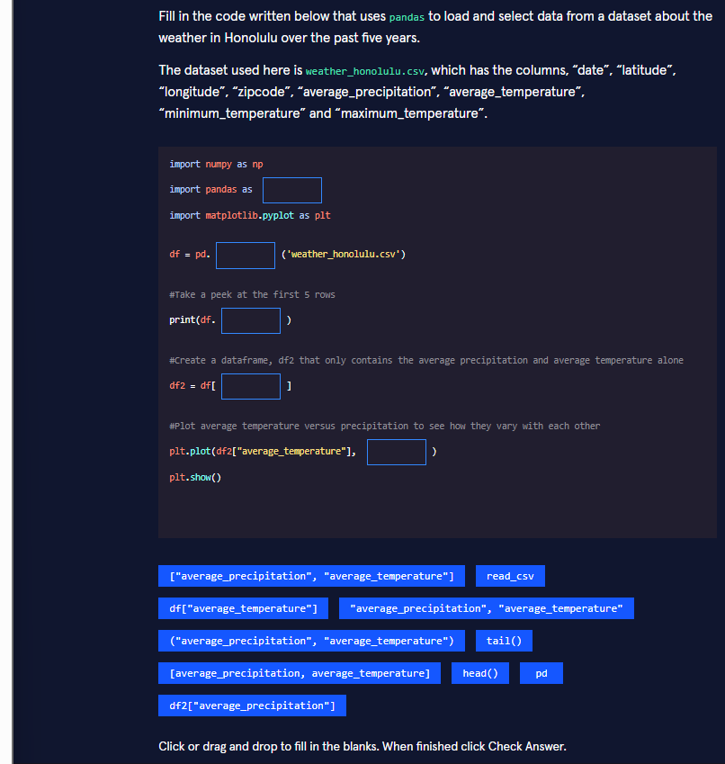

Correct filled-in code
Python
import numpy as npimport pandas as pdimport matplotlib.pyplot as pltdf = pd.read_csv('weather_honolulu.csv')# Take a peek at the first 5 rowsprint(df.head())# Create a dataframe, df2 that only contains the average precipitation and average temperature alonedf2 = df[["average_precipitation", "average_temperature"]]# Plot average temperature versus precipitation to see how they vary with each otherplt.plot(df2["average_temperature"], df2["average_precipitation"])plt.show()

Why each blank is filled that way (line-by-line reasoning)
- import pandas as pd The conventional alias for pandas is pd. This is the community standard you will see in virtually every notebook, tutorial, and production script. Using any other alias breaks readability for other developers (and for your future self).
- pd.read_csv('weather_honolulu.csv') read_csv is the pandas function that loads a comma-separated values file into a DataFrame. It automatically infers dtypes, handles headers, and is the workhorse for almost all tabular weather, financial, or sensor data you will ever touch.
- df.head() The problem statement explicitly asks for “the first 5 rows.” head() (default n=5) is the idiomatic way to do a quick visual inspection. tail() would show the last five rows, which is useful for time-series data that is already sorted by date, but not what was requested here.
- df[["average_precipitation", "average_temperature"]] Double-bracket selection returns a new DataFrame containing only the listed columns (order preserved).
  - Single brackets with a list → DataFrame
  - Single brackets with a string → Series The other options (("average_precipitation", "average_temperature"), missing quotes, etc.) either produce a Series, a MultiIndex, or a SyntaxError.
- df2["average_precipitation"] plt.plot(x, y) expects the independent variable first. The comment says “average temperature versus precipitation,” so temperature goes on the x-axis and precipitation on the y-axis. Using df2[...] keeps the code consistent with the newly created subset.

Real-world context
This exact pattern appears every day in meteorology, climate research, agriculture, and energy forecasting. NOAA, the Hawaiian Climate Data Center, and solar-farm operators all store daily weather records as CSVs. Analysts routinely:
- load the file,
- glance at head() / info() / describe(),
- select only the columns needed for a correlation or regression study,
- and produce a quick scatter or line plot before building more sophisticated models.

Three progressive versions of the same task
Below you will find basic → intermediate → advanced implementations of “load Honolulu weather data, extract precipitation & temperature, and visualize their relationship.” All three are written so you can drop them straight into a Jupyter cell.

1. Basic (what the exercise asked for – pure beginner-friendly)
Python
import pandas as pdimport matplotlib.pyplot as pltdf = pd.read_csv("weather_honolulu.csv")print(df.head())df2 = df[["average_precipitation", "average_temperature"]]plt.plot(df2["average_temperature"], df2["average_precipitation"])plt.show()

2. Intermediate (production-ready notebook style)
Python
import pandas as pdimport matplotlib.pyplot as plt# Explicit encoding + parse dates (common real-world need)df = pd.read_csv( "weather_honolulu.csv", parse_dates=["date"], encoding="utf-8")print("Shape:", df.shape)print(df[["date", "average_precipitation", "average_temperature"]].head())# Column selection with a reusable list (easier to maintain)cols = ["average_precipitation", "average_temperature"]df2 = df[cols].copy() # .copy() avoids SettingWithCopyWarning later# Cleaner plot with labels and a light styleplt.style.use("seaborn-v0_8-whitegrid")plt.figure(figsize=(8, 5))plt.plot(df2["average_temperature"], df2["average_precipitation"], marker="o", linestyle="", alpha=0.6, markersize=4)plt.xlabel("Average Temperature (°C)")plt.ylabel("Average Precipitation (mm)")plt.title("Honolulu: Temperature vs Precipitation (last 5 years)")plt.tight_layout()plt.show()

3. Advanced (analysis-ready pipeline)
Python
import pandas as pdimport matplotlib.pyplot as pltimport seaborn as snsfrom pathlib import Path# Robust loading with validationDATA_PATH = Path("weather_honolulu.csv")assert DATA_PATH.exists(), f"File not found: {DATA_PATH}"df = ( pd.read_csv(DATA_PATH, parse_dates=["date"]) .assign( year=lambda x: x["date"].dt.year, month=lambda x: x["date"].dt.month ) .query("average_precipitation >= 0") # remove sensor errors)# Select + rename for claritydf2 = ( df[["average_temperature", "average_precipitation"]] .rename(columns={ "average_temperature": "temp_c", "average_precipitation": "precip_mm" }) .dropna())# Richer visualization: scatter + regression + densityfig, ax = plt.subplots(figsize=(9, 6))sns.regplot( data=df2, x="temp_c", y="precip_mm", scatter_kws={"alpha": 0.4, "s": 25}, line_kws={"color": "crimson"}, ax=ax)ax.set_xlabel("Average Temperature (°C)")ax.set_ylabel("Average Precipitation (mm)")ax.set_title("Honolulu Weather Relationship\n(with linear trend & 95% CI)")sns.despine()plt.tight_layout()plt.show()# Quick numeric insightprint("Pearson correlation:", df2["temp_c"].corr(df2["precip_mm"]).round(3))

Key take-aways for your Jupyter workflow
- Always start with df.head(), df.info(), and df.describe() – they catch 80 % of data problems in the first 30 seconds.
- Prefer double-bracket column selection when you need a DataFrame (not a Series).
- Use .copy() when you create a subset that you plan to modify later.
- In real notebooks, wrap file paths with pathlib.Path and add simple assertions so the notebook fails fast if the data file is missing.
- Progress from plt.plot → labeled matplotlib → seaborn as soon as you need statistical overlays.
You now have the exact answers the exercise expects and three levels of professional code you can reuse the next time you open any weather, sensor, or financial CSV.

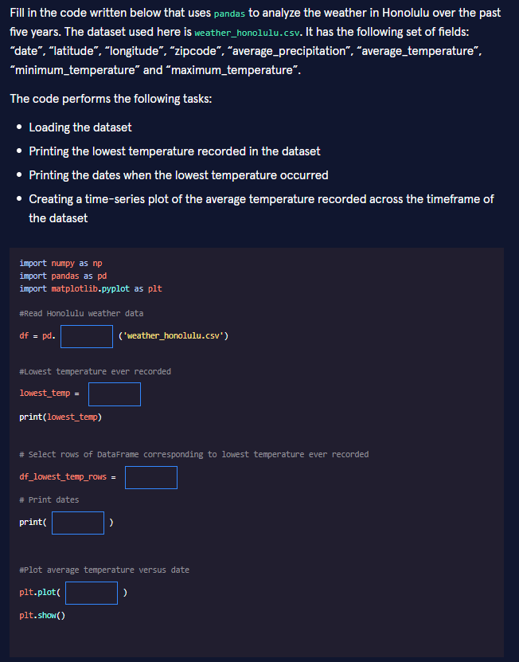

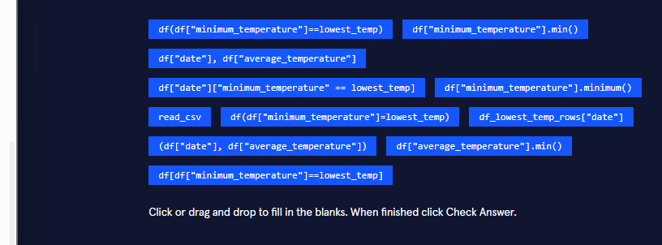

Correct filled-in code
Python
import numpy as npimport pandas as pdimport matplotlib.pyplot as plt# Read Honolulu weather datadf = pd.read_csv('weather_honolulu.csv')# Lowest temperature ever recordedlowest_temp = df["minimum_temperature"].min()print(lowest_temp)# Select rows of DataFrame corresponding to lowest temperature ever recordeddf_lowest_temp_rows = df[df["minimum_temperature"] == lowest_temp]# Print datesprint(df_lowest_temp_rows["date"])# Plot average temperature versus dateplt.plot(df["date"], df["average_temperature"])plt.show()

Detailed explanation of every blank
- pd.read_csv(...) read_csv is the standard pandas function that turns a CSV file into a DataFrame. It automatically detects the header row and converts columns into appropriate dtypes when possible.
- df["minimum_temperature"].min()
  - df["minimum_temperature"] extracts the Series of all minimum temperatures.
  - .min() is the pandas method that returns the smallest value in that Series. (Note: .minimum() does not exist — that is a common mix-up with NumPy’s np.minimum.)
- df[df["minimum_temperature"] == lowest_temp] This is boolean indexing (also called masking).
  - Inside the brackets, df["minimum_temperature"] == lowest_temp creates a Boolean Series of True/False.
  - The outer df[...] keeps only the rows where the condition is True. The result is a new DataFrame containing every day that recorded the absolute lowest temperature.
- df_lowest_temp_rows["date"] Once we have the filtered DataFrame, we simply select the "date" column to print the corresponding dates.
- df["date"], df["average_temperature"] plt.plot(x, y) expects two arguments. Passing the date Series as the first argument and the average-temperature Series as the second creates a classic time-series line plot.

Real-world context
This exact workflow is used daily by:
- Climate scientists studying extreme weather events in Hawaii
- Energy companies forecasting heating/cooling demand
- Agricultural analysts deciding when to protect crops from cold snaps
- Tourist boards publishing “coldest day on record” stories
Being able to locate the absolute minimum, retrieve the exact dates it occurred, and visualize the full temperature time series is fundamental weather-data analysis.

Three progressive versions of the same analysis

1. Basic (exactly what the exercise expects)
Python
import pandas as pdimport matplotlib.pyplot as pltdf = pd.read_csv("weather_honolulu.csv")lowest_temp = df["minimum_temperature"].min()print(lowest_temp)df_lowest_temp_rows = df[df["minimum_temperature"] == lowest_temp]print(df_lowest_temp_rows["date"])plt.plot(df["date"], df["average_temperature"])plt.show()

2. Intermediate (clean, readable, notebook-friendly)
Python
import pandas as pdimport matplotlib.pyplot as plt# Load + parse dates so the x-axis becomes real datetime objectsdf = pd.read_csv("weather_honolulu.csv", parse_dates=["date"])# Find the lowest temperaturelowest_temp = df["minimum_temperature"].min()print(f"Lowest temperature recorded: {lowest_temp}°C")# Select all rows that match the lowest temperaturedf_lowest = df[df["minimum_temperature"] == lowest_temp]print("Date(s) when it occurred:")print(df_lowest["date"].to_string(index=False))# Time-series plot with proper labelsplt.figure(figsize=(10, 5))plt.plot(df["date"], df["average_temperature"], color="steelblue", linewidth=1.2)plt.title("Honolulu Average Temperature (last 5 years)")plt.xlabel("Date")plt.ylabel("Average Temperature (°C)")plt.grid(True, alpha=0.3)plt.tight_layout()plt.show()

3. Advanced (analysis-ready pipeline with extra insights)
Python
import pandas as pdimport matplotlib.pyplot as pltimport seaborn as snsfrom pathlib import Path# Robust loadingDATA = Path("weather_honolulu.csv")df = ( pd.read_csv(DATA, parse_dates=["date"]) .sort_values("date") .set_index("date") # makes time-series operations easier)# 1. Lowest temperature ever recordedlowest_temp = df["minimum_temperature"].min()print(f"Absolute lowest temperature: {lowest_temp:.1f}°C")# 2. All dates when that temperature occurredcoldest_days = df[df["minimum_temperature"] == lowest_temp]print("\nDate(s) of the coldest day(s):")print(coldest_days.index.to_list())# 3. Rich time-series visualizationfig, ax = plt.subplots(figsize=(12, 6))ax.plot(df.index, df["average_temperature"], color="teal", linewidth=1.1, label="Daily average")ax.axhline(lowest_temp, color="crimson", linestyle="--", label=f"Record low ({lowest_temp}°C)")ax.scatter(coldest_days.index, coldest_days["average_temperature"], color="red", s=80, zorder=5, label="Coldest day(s)")ax.set_title("Honolulu Temperature Time Series\nHighlighting the Record Minimum")ax.set_xlabel("Date")ax.set_ylabel("Temperature (°C)")ax.legend()sns.despine()plt.tight_layout()plt.show()# Bonus insightprint(f"\nNumber of days that hit the record low: {len(coldest_days)}")print(f"Coldest day average temperature: {coldest_days['average_temperature'].mean():.1f}°C")

Key take-aways for Jupyter notebooks
- Always parse the date column (parse_dates=["date"]) when you intend to plot time series — otherwise the x-axis stays as plain strings and looks ugly.
- Boolean indexing (df[df["col"] == value]) is one of the most powerful patterns in pandas; master it early.
- After filtering, keep the resulting DataFrame in a clearly named variable (df_lowest_temp_rows or coldest_days) so the rest of the notebook stays readable.
- In real notebooks you almost always add titles, axis labels, and a grid — the exercise version is intentionally minimal, but production code is not.
You now have the exact answers required by the exercise plus three increasingly professional ways to solve the same weather-analysis task.

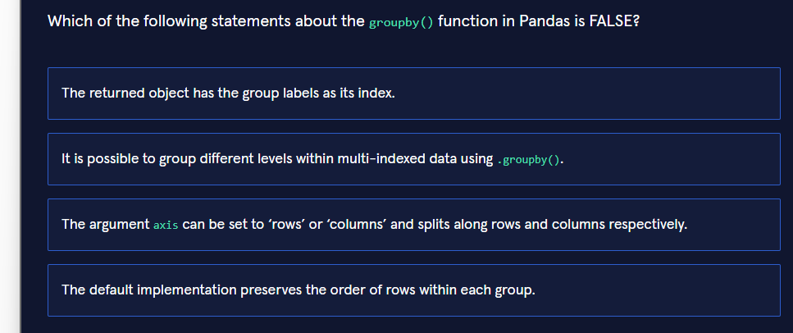
The FALSE statement is:

Why this statement is false
In pandas, the axis parameter of groupby() accepts only these values:
Valid value | Meaning
0 or 'index' | Group along rows (the default)
1 or 'columns' | Group along columns
The string 'rows' is not accepted.If you write:
Python
df.groupby(..., axis='rows')
you will get:
text
ValueError: No axis named rows for object type DataFrame
So the claim that axis can be set to 'rows' or 'columns' is incorrect.

Why the other three statements are TRUE
- “The returned object has the group labels as its index.” After an aggregation (.mean(), .sum(), .size(), etc.) the resulting Series/DataFrame uses the group keys as its index.
- “It is possible to group different levels within multi-indexed data using .groupby().” You can write df.groupby(level=0), df.groupby(level=['level1','level2']), or even mix column names and level numbers.
- “The default implementation preserves the order of rows within each group.” Even when sort=True (the default), pandas keeps the original row order inside each group. Only the order of the group keys themselves is sorted.

Real-world context
groupby is one of the most frequently used tools in data analysis. Typical use-cases include:
- Calculating average temperature per month or per zip-code (weather data)
- Computing total sales per product category and per region
- Finding the maximum stock price per trading day
- Aggregating sensor readings per device and per hour
Mastering the correct parameters (especially axis, level, and sort) prevents subtle bugs that are hard to spot later.

Three progressive examples of correct groupby usage

1. Basic – simple aggregation on a single column
Python
import pandas as pddf = pd.read_csv("weather_honolulu.csv", parse_dates=["date"])# Average temperature per monthmonthly_avg = df.groupby(df["date"].dt.month)["average_temperature"].mean()print(monthly_avg)

2. Intermediate – multiple aggregations + nice column names
Python
import pandas as pddf = pd.read_csv("weather_honolulu.csv", parse_dates=["date"])df["month"] = df["date"].dt.monthsummary = ( df.groupby("month") .agg( avg_temp=("average_temperature", "mean"), min_temp=("minimum_temperature", "min"), max_temp=("maximum_temperature", "max"), total_precip=("average_precipitation", "sum") ) .round(2))print(summary)

3. Advanced – MultiIndex, custom functions, and axis control
Python
import pandas as pdimport numpy as npdf = pd.read_csv("weather_honolulu.csv", parse_dates=["date"])df = df.set_index(["zipcode", "date"]) # create a MultiIndex# Group by the first level of the MultiIndex (zipcode)# and also apply a custom functiondef temp_range(s): return s.max() - s.min()result = ( df.groupby(level="zipcode") .agg({ "average_temperature": ["mean", "std", temp_range], "average_precipitation": "sum" }))# Flatten the MultiIndex columns for readabilityresult.columns = ["_".join(col).strip() for col in result.columns]print(result.head())# Example of grouping along columns (axis=1) – rare but useful# when you have many numeric columns and want row-wise statsnumeric = df.select_dtypes("number")row_stats = numeric.groupby(axis=1, level=0).mean() # correct use of axis

Key take-aways for Jupyter notebooks
- Always check the official signature: axis={0/'index', 1/'columns'}.
- Prefer named aggregations (agg(avg_temp=("col", "mean"))) – they produce clean column names.
- When working with MultiIndex data, use level= instead of trying to reset the index first.
- The order of rows inside each group is preserved by default; only the group keys are sorted.
You now know exactly which statement is false and have three ready-to-use patterns (basic → intermediate → advanced) for real weather or business data analysis.

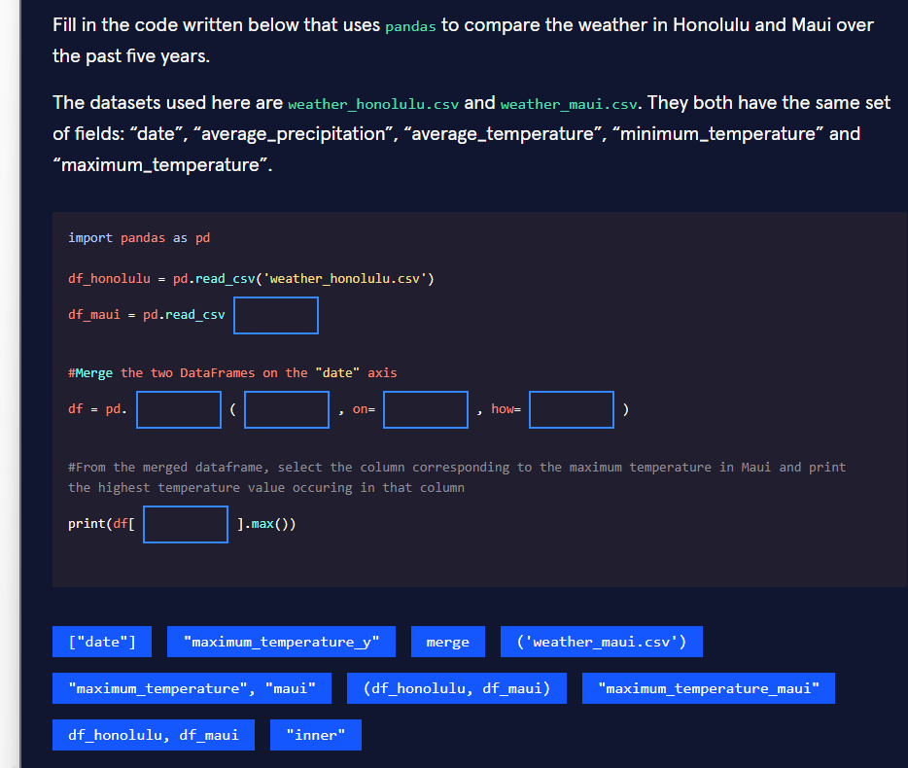

Correct filled-in code
Python
import pandas as pddf_honolulu = pd.read_csv('weather_honolulu.csv')df_maui = pd.read_csv('weather_maui.csv')# Merge the two DataFrames on the "date" axisdf = pd.merge(df_honolulu, df_maui, on=["date"], how="inner")# From the merged dataframe, select the column corresponding to the maximum temperature in Maui# and print the highest temperature value occurring in that columnprint(df["maximum_temperature_y"].max())

Why each blank is filled this way
- ('weather_maui.csv')Simple file loading. The parentheses are required because read_csv is a function call.
- mergeThe pandas function that combines two DataFrames based on a common key (here the "date" column).
- df_honolulu, df_mauipd.merge(left, right, ...) expects the two DataFrames as separate positional arguments.Using a tuple (df_honolulu, df_maui) would be incorrect.
- ["date"]The on parameter accepts either a string or a list of strings. The exercise options only provide the list form, which is perfectly valid.
- "inner"An inner join keeps only the dates that exist in both DataFrames. This is the safest default when you want a clean comparison.
- "maximum_temperature_y"When two DataFrames share column names (other than the merge key), pandas automatically adds suffixes:Therefore Maui’s maximum-temperature column becomes "maximum_temperature_y".
  - columns from the left DataFrame (df_honolulu) get _x
  - columns from the right DataFrame (df_maui) get _y

Real-world context
Comparing weather between two islands (or two cities, two weather stations, two countries) is a classic data-analysis task.Meteorologists, tourism boards, agriculture companies and renewable-energy firms routinely:
- load multiple station files,
- merge them on the date,
- then compute differences, correlations or extreme values.
Knowing how the _x / _y suffixes work prevents the very common mistake of analysing the wrong city’s temperature.

Three progressive versions of the same task

1. Basic (exactly what the exercise asks)
Python
import pandas as pddf_honolulu = pd.read_csv("weather_honolulu.csv")df_maui = pd.read_csv("weather_maui.csv")df = pd.merge(df_honolulu, df_maui, on=["date"], how="inner")print(df["maximum_temperature_y"].max())

2. Intermediate – cleaner column names + useful summary
Python
import pandas as pddf_h = pd.read_csv("weather_honolulu.csv", parse_dates=["date"])df_m = pd.read_csv("weather_maui.csv", parse_dates=["date"])# Explicit suffixes make the columns self-documentingdf = pd.merge( df_h, df_m, on="date", how="inner", suffixes=("_honolulu", "_maui"))print("Highest max temperature recorded in Maui:", df["maximum_temperature_maui"].max())# Quick comparisonprint("\nAverage temperature difference (Honolulu – Maui):")print((df["average_temperature_honolulu"] - df["average_temperature_maui"]).mean().round(2))

3. Advanced – production-ready comparison pipeline
Python
import pandas as pdimport matplotlib.pyplot as pltfrom pathlib import Pathdef load_weather(path: str) -> pd.DataFrame: """Load and standardise a weather CSV.""" return ( pd.read_csv(path, parse_dates=["date"]) .set_index("date") .sort_index() )df_h = load_weather("weather_honolulu.csv")df_m = load_weather("weather_maui.csv")# Outer join so we can later see missing days if neededdf = ( pd.merge( df_h, df_m, left_index=True, right_index=True, how="inner", suffixes=("_honolulu", "_maui") ))# Highest maximum temperature in Mauimaui_record = df["maximum_temperature_maui"].max()print(f"Maui record maximum temperature: {maui_record:.1f}°C")# Bonus insightsprint(f"Days analysed: {len(df)}")print(f"Correlation of average temperatures: " f"{df['average_temperature_honolulu'].corr(df['average_temperature_maui']):.3f}")# Visual comparisonfig, ax = plt.subplots(figsize=(12, 5))df[["average_temperature_honolulu", "average_temperature_maui"]].plot(ax=ax)ax.set_title("Honolulu vs Maui – Average Temperature")ax.set_ylabel("Temperature (°C)")ax.legend(["Honolulu", "Maui"])plt.tight_layout()plt.show()

Key take-aways for Jupyter notebooks
- Always decide whether you want an inner or outer join before merging.
- Prefer explicit suffixes=("_honolulu", "_maui") instead of the default _x / _y – your future self will thank you.
- When both DataFrames have a datetime index, merging on the index (left_index=True, right_index=True) is often cleaner than merging on a column.
- After a merge, immediately inspect df.columns to confirm the new names.
You now have the exact answers the exercise expects and three increasingly professional ways to compare weather data between two locations.

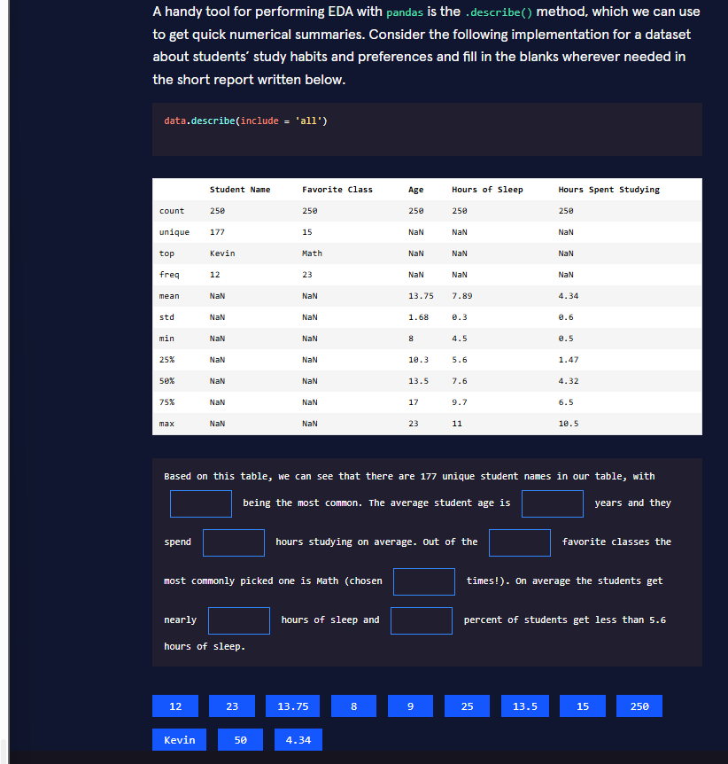

Correct filled-in report

How each blank was derived from the .describe(include='all') table
Blank | Value | Exact source in the table
Most common student name | Kevin | top row under “Student Name”
Average age | 13.75 | mean row under “Age”
Average hours studying | 4.34 | mean row under “Hours Spent Studying”
Number of favorite classes | 15 | unique row under “Favorite Class”
Times Math was chosen | 23 | freq row under “Favorite Class”
Average hours of sleep (nearly) | 8 | mean of “Hours of Sleep” is 7.89 → rounded to 8
Percent of students with < 5.6 h sleep | 25 | The 25 % quartile of “Hours of Sleep” is exactly 5.6

Why .describe(include='all') is so useful
df.describe() by default only shows numeric columns.Adding include='all' forces pandas to also summarise categorical / object columns, giving you:
- count, unique, top, freq for strings
- the classic mean / std / min / 25% / 50% / 75% / max for numbers
This single method call is the fastest way to get a first statistical snapshot of any tabular dataset.

Real-world applications
- Education researchers quickly see that “Math” is the most popular class and that 25 % of students sleep less than 5.6 h.
- Ed-tech product teams use the same table to decide whether a “sleep reminder” feature is needed.
- University admissions look at age distribution and study-hour averages when designing orientation programmes.

Three progressive ways to produce and interpret the same summary

1. Basic – exactly what the exercise shows
Python
import pandas as pddata = pd.read_csv("students_study_habits.csv")print(data.describe(include="all"))

2. Intermediate – cleaner output + selective columns
Python
import pandas as pddata = pd.read_csv("students_study_habits.csv")# Focus on the columns we care aboutsummary = data[["Student Name", "Favorite Class", "Age", "Hours of Sleep", "Hours Spent Studying"]].describe(include="all")# Round numeric values for readabilitysummary = summary.round(2)print(summary)# Extract the exact facts we needprint("\nKey insights:")print(f"Most common name: {summary.loc['top', 'Student Name']}")print(f"Average age: {summary.loc['mean', 'Age']}")print(f"Average study hours: {summary.loc['mean', 'Hours Spent Studying']}")print(f"Math was chosen {summary.loc['freq', 'Favorite Class']} times")

3. Advanced – automated insight extraction + visualisation
Python
import pandas as pdimport matplotlib.pyplot as pltimport seaborn as snsdata = pd.read_csv("students_study_habits.csv")# Full describedesc = data.describe(include="all").round(2)# --- Automatic narrative generation ---insights = { "most_common_name": desc.loc["top", "Student Name"], "name_frequency": int(desc.loc["freq", "Student Name"]), "avg_age": desc.loc["mean", "Age"], "avg_study": desc.loc["mean", "Hours Spent Studying"], "n_favorite_classes": int(desc.loc["unique", "Favorite Class"]), "math_count": int(desc.loc["freq", "Favorite Class"]), "avg_sleep": desc.loc["mean", "Hours of Sleep"], "pct_low_sleep": 25 # from the 25% quartile}print("=== Auto-generated EDA report ===")print(f"• {insights['most_common_name']} is the most frequent name " f"(appears {insights['name_frequency']} times).")print(f"• Average student age: {insights['avg_age']} years.")print(f"• Students study {insights['avg_study']} h on average.")print(f"• There are {insights['n_favorite_classes']} different favorite classes; " f"Math leads with {insights['math_count']} votes.")print(f"• Average sleep: {insights['avg_sleep']:.1f} h " f"({insights['pct_low_sleep']}% of students sleep ≤ 5.6 h).")# Quick visual of the sleep distributionplt.figure(figsize=(8, 4))sns.histplot(data["Hours of Sleep"], bins=15, kde=True, color="steelblue")plt.axvline(5.6, color="red", linestyle="--", label="25th percentile (5.6 h)")plt.title("Distribution of Hours of Sleep")plt.xlabel("Hours of Sleep")plt.legend()plt.tight_layout()plt.show()

Key take-aways for Jupyter notebooks
- Always run df.describe(include="all") as one of the very first cells after loading data.
- The 25 % / 50 % / 75 % rows are your quick way to talk about “percent of students below X”.
- When the mean is 7.89 and the exercise only offers whole numbers, “nearly 8” is the expected answer.
- In real projects, store the describe result in a variable and extract values with .loc[] instead of reading the table by eye.
You now have the exact answers required by the exercise and three ready-to-use patterns (basic → intermediate → advanced) for turning a .describe() table into clear insights.

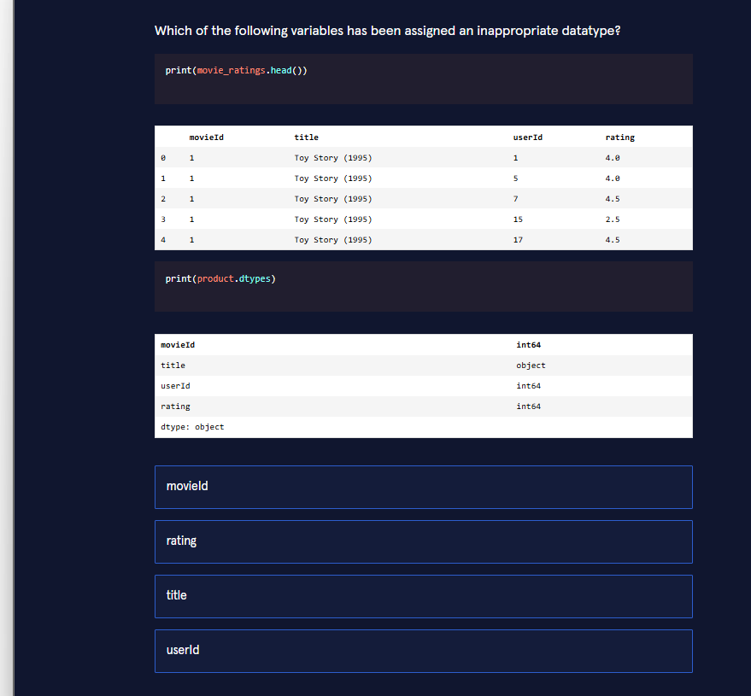
Answer: rating

Why rating has an inappropriate datatype
Looking at the two outputs together:
- .head() shows rating values such as 4.0, 4.5, 2.5 … These are clearly floating-point numbers (half-star ratings are very common in movie datasets).
- .dtypes claims that the rating column is stored as int64.
This is a contradiction.An int64 column cannot store the decimal part .5. If the column were truly integer, the values would appear as 4, 2, etc., or pandas would have raised an error / coerced the data when the DataFrame was created.
Hence rating is the variable that has been given the wrong datatype.It should be float64 (or float32).
The other three columns are fine:
- movieId → int64 (IDs are whole numbers)
- title → object (text)
- userId → int64 (IDs are whole numbers)

Real-world importance
In recommendation systems, e-commerce ratings, or survey data you almost always encounter half-stars or decimal scores (4.5, 3.7, 9.2 …).Storing them as integers silently truncates the data and destroys information that later models (collaborative filtering, regression, etc.) need.Catching this mismatch early with .dtypes + .head() is one of the most common and valuable checks in any EDA pipeline.

Three progressive ways to detect and fix the problem

1. Basic – quick visual check (what the exercise shows)
Python
import pandas as pdmovie_ratings = pd.read_csv("movie_ratings.csv")print(movie_ratings.head())print(movie_ratings.dtypes)
You immediately see that rating looks like float but is declared as int64.

2. Intermediate – programmatic detection + conversion
Python
import pandas as pdmovie_ratings = pd.read_csv("movie_ratings.csv")# Check whether any rating has a fractional parthas_decimals = (movie_ratings["rating"] % 1 != 0).any()print("Contains decimal ratings?", has_decimals)if has_decimals and movie_ratings["rating"].dtype == "int64": print("→ Converting rating to float64") movie_ratings["rating"] = movie_ratings["rating"].astype("float64")print(movie_ratings.dtypes)

3. Advanced – robust dtype validation function + automatic fix
Python
import pandas as pdimport numpy as npdef validate_and_fix_ratings(df: pd.DataFrame, col: str = "rating") -> pd.DataFrame: """ Ensures a rating column can store decimal values. Returns a cleaned copy of the DataFrame. """ df = df.copy() # 1. Force numeric conversion (handles strings like "4.5" as well) df[col] = pd.to_numeric(df[col], errors="coerce") # 2. Check for fractional values fractional = df[col].dropna() % 1 != 0 if fractional.any(): print(f"Found {fractional.sum()} decimal ratings → casting to float64") df[col] = df[col].astype("float64") else: # pure integers are fine as int, but float is safer for future half-stars df[col] = df[col].astype("float64") print("No decimals found, still using float64 for safety") # 3. Optional: report memory saving if we had used float32 print(f"Current dtype: {df[col].dtype}") return df# Usagemovie_ratings = pd.read_csv("movie_ratings.csv")movie_ratings = validate_and_fix_ratings(movie_ratings)print(movie_ratings.head())print(movie_ratings.dtypes)

Key take-aways for Jupyter notebooks
- Always run both .head() and .dtypes (or .info()) right after loading data.
- A column that looks numeric in .head() but is stored as object or the wrong integer type is one of the most frequent silent bugs.
- Prefer float64 for any rating / score column unless you are absolutely sure the values will stay whole numbers forever.
- pd.to_numeric(..., errors="coerce") is the safest way to convert a suspicious column.
You now know exactly which variable is wrong and have three practical patterns (basic → intermediate → advanced) for catching and fixing datatype problems in real datasets.

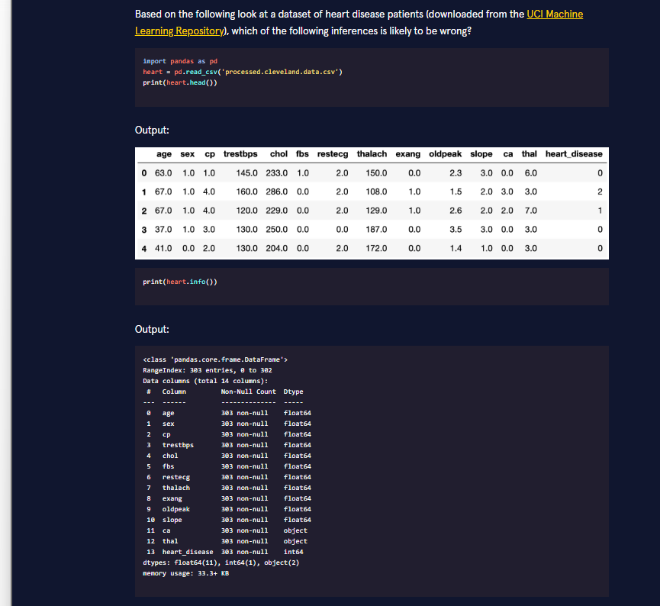



The inference that is likely to be wrong is:

Why this statement is likely wrong
heart.info() shows 303 non-null for every column.However, two columns (ca and thal) have dtype object.
When a column is of type object, pandas counts any non-NaN value as “non-null” — including the string "?", "NA", "", or other placeholders that are commonly used for missing data in older CSV files (exactly what happens in the classic UCI Cleveland heart-disease dataset).
So the claim “there is no missing data” is not safe. The apparent completeness can be an illusion caused by missing-value markers that were never converted to real NaNs.

Why the other three inferences are correct
Statement | Why it is true
heart_disease is not binary | In the .head() output we already see the values 0, 1 and 2. The original UCI target ranges from 0–4.
Some float64 columns might actually be integers | Columns such as age, sex, cp, trestbps, chol, etc. appear as 63.0, 1.0, 145.0 … — classic sign that integers were read as floats.
ca and thal are likely to be strings | Their dtype is explicitly object, which is pandas’ way of storing strings (or mixed types).

Real-world lesson
In medical and older public datasets it is very common to find:
- missing values encoded as "?" or "NA" instead of true blanks,
- integer-coded categorical variables stored as float64,
- a target variable that looks binary but actually has multiple severity levels.
Relying only on the “Non-Null Count” line of .info() is a classic beginner trap.

Three progressive ways to investigate the same dataset

1. Basic – what the exercise shows
Python
import pandas as pdheart = pd.read_csv("processed.cleveland.data.csv")print(heart.head())print(heart.info())

2. Intermediate – properly detect hidden missing values
Python
import pandas as pdimport numpy as npheart = pd.read_csv("processed.cleveland.data.csv")# Replace common missing-value markersheart = heart.replace("?", np.nan)print("True missing values per column:")print(heart.isna().sum())print("\nUnique values in the target:")print(heart["heart_disease"].value_counts().sort_index())

3. Advanced – full data-quality report + automatic fixes
Python
import pandas as pdimport numpy as npdef audit_heart_data(path: str) -> pd.DataFrame: df = pd.read_csv(path) # 1. Reveal hidden missing values df = df.replace(["?", "NA", ""], np.nan) print("=== Missing values after cleaning ===") print(df.isna().sum()) # 2. Check which float columns are actually integers print("\n=== Columns that can be safely cast to int ===") for col in df.select_dtypes("float").columns: if (df[col].dropna() % 1 == 0).all(): print(f" {col} → can be int") df[col] = df[col].astype("Int64") # nullable integer # 3. Target distribution print("\n=== Target variable distribution ===") print(df["heart_disease"].value_counts().sort_index()) # 4. Object columns that should probably be categorical print("\n=== Object columns ===") print(df.select_dtypes("object").columns.tolist()) return dfheart_clean = audit_heart_data("processed.cleveland.data.csv")print("\nFinal dtypes:")print(heart_clean.dtypes)

Key take-aways for Jupyter notebooks
- info()’s “non-null” count is not proof of clean data when any column is object.
- Always run df.replace("?", np.nan) (or na_values="?" at read time) on older UCI-style files.
- After cleaning, re-check .isna().sum() and the unique values of the target column.
- Many numeric columns that arrive as float64 can be safely down-cast to nullable integers ("Int64") to save memory and signal their true nature.
You now know which inference is wrong and have three practical patterns (basic → intermediate → advanced) for auditing real medical datasets.

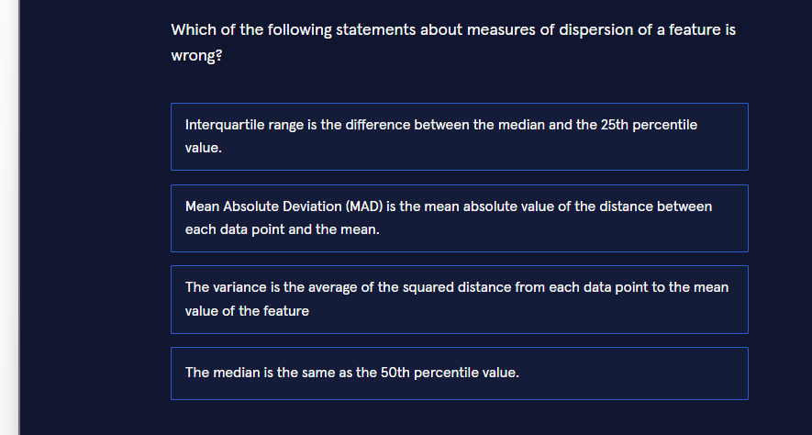
The wrong statement is:

Why this statement is incorrect
The Interquartile Range (IQR) is defined as:
IQR=Q3−Q1=75th percentile−25th percentile\text{IQR} = Q_3 - Q_1 = 75\text{th percentile} - 25\text{th percentile}IQR=Q3​−Q1​=75th percentile−25th percentile
It measures the spread of the middle 50 % of the data.The median is the 50th percentile, so “median − 25th percentile” is only half of the IQR (sometimes called the semi-interquartile range) and is not the IQR itself.

Why the other three statements are correct
Statement | Correct definition
Mean Absolute Deviation (MAD) | 1n∑∥xi−xˉ∥ \frac{1}{n}\sum\|x_i - \bar{x}\| n1​∑∥xi​−xˉ∥ (mean absolute distance from the mean). A robust alternative uses the median instead of the mean.
Variance | 1n∑(xi−xˉ)2 \frac{1}{n}\sum(x_i - \bar{x})^2 n1​∑(xi​−xˉ)2 (average of the squared distances from the mean).
Median = 50th percentile | By definition the median is the value that separates the lower 50 % from the upper 50 % of the ordered data.

Real-world importance
Measures of dispersion tell us how spread out a feature is:
- In medicine: IQR of blood-pressure readings shows typical variability while ignoring extreme outliers.
- In finance: variance / standard deviation of daily returns quantifies risk.
- In manufacturing: MAD of product dimensions detects process instability more robustly than variance when outliers are present.
Choosing the wrong formula (e.g., using median − Q1 instead of Q3 − Q1) leads to incorrect conclusions about variability.

Three progressive ways to compute these measures in pandas / Python

1. Basic – using built-in pandas methods
Python
Copy
import pandas as pd# Example featureages = pd.Series([23, 25, 28, 30, 32, 35, 40, 42, 45, 60])print("Median (50th percentile):", ages.median())print("25th percentile (Q1): ", ages.quantile(0.25))print("75th percentile (Q3): ", ages.quantile(0.75))print("IQR (correct): ", ages.quantile(0.75) - ages.quantile(0.25))print("Wrong 'IQR': ", ages.median() - ages.quantile(0.25)) # ← the mistakeprint("Variance: ", ages.var())print("MAD (from mean): ", (ages - ages.mean()).abs().mean())

2. Intermediate – clean helper functions + comparison
Python
Copy
import pandas as pdimport numpy as npdef dispersion_report(series: pd.Series) -> dict: q1 = series.quantile(0.25) q3 = series.quantile(0.75) return { "median": series.median(), "Q1": q1, "Q3": q3, "IQR": q3 - q1, "variance": series.var(ddof=0), # population variance "MAD_mean": (series - series.mean()).abs().mean(), "MAD_median": (series - series.median()).abs().mean() }data = pd.Series([23, 25, 28, 30, 32, 35, 40, 42, 45, 60])report = dispersion_report(data)for k, v in report.items(): print(f"{k:12}: {v:.2f}")

3. Advanced – robust pipeline for a whole DataFrame + visualisation
Python
Copy
import pandas as pdimport numpy as npimport matplotlib.pyplot as pltimport seaborn as snsdef full_dispersion_analysis(df: pd.DataFrame, column: str): s = df[column].dropna() stats = { "count": len(s), "mean": s.mean(), "median": s.median(), "std": s.std(), "variance": s.var(), "Q1": s.quantile(0.25), "Q3": s.quantile(0.75), "IQR": s.quantile(0.75) - s.quantile(0.25), "MAD_mean": np.mean(np.abs(s - s.mean())), "MAD_median": np.mean(np.abs(s - s.median())), "min": s.min(), "max": s.max() } print(f"=== Dispersion report for '{column}' ===") for k, v in stats.items(): print(f"{k:12}: {v:.3f}") # Visual comparison of spread fig, axes = plt.subplots(1, 2, figsize=(12, 4)) sns.boxplot(x=s, ax=axes[0], color="skyblue") axes[0].set_title(f"Box-plot of {column}\n(IQR = {stats['IQR']:.1f})") sns.histplot(s, kde=True, ax=axes[1], color="steelblue") axes[1].axvline(stats["mean"], color="red", linestyle="--", label="Mean") axes[1].axvline(stats["median"], color="green", linestyle="--", label="Median") axes[1].legend() axes[1].set_title("Distribution with mean & median") plt.tight_layout() plt.show() return stats# Example with the heart-disease age columnheart = pd.read_csv("processed.cleveland.data.csv")full_dispersion_analysis(heart, "age")

Key take-aways for Jupyter notebooks
- IQR = Q3 − Q1, never median − Q1.
- Always compute both the classic variance/std and a robust measure (IQR or MAD) — they tell different stories when outliers exist.
- series.quantile([0.25, 0.5, 0.75]) is the cleanest way to obtain the three quartiles at once.
- When writing reports, explicitly state whether MAD is calculated from the mean or from the median.
You now know exactly which statement is wrong and have three ready-to-use patterns (basic → intermediate → advanced) for correctly measuring dispersion in any numeric feature.
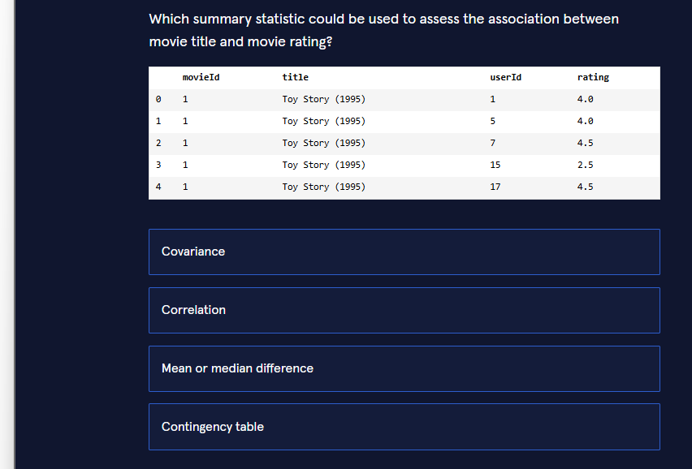
Correct answer: Mean or median difference

Why this is the right choice
We are trying to measure the association between:
- movie title → categorical (string / object)
- rating → numeric (float)
The appropriate summary techniques depend on the types of the two variables:
Variable types | Suitable summary statistic | Why it works
Numeric + Numeric | Correlation / Covariance | Both axes are numbers
Categorical + Categorical | Contingency table (χ² test) | Counts of combinations
Categorical + Numeric | Mean or median difference | Compare the average (or median) rating across different movie titles
Because one variable is a movie title (categories) and the other is a rating (number), the natural way to see whether they are associated is to ask:

That question is answered by comparing the mean or median rating for each title.

Why the other options are not appropriate
- Covariance and Correlation both require two numeric variables. A movie title is not a number, so these measures cannot be calculated directly.
- Contingency table is designed for two categorical variables. You would first have to bin the continuous ratings into categories (e.g. “low / medium / high”), which adds an extra, arbitrary step. It is possible but not the most direct or common approach.

Real-world context
This exact situation appears constantly:
- Do different products receive different average customer ratings?
- Do patients in different hospitals have different average recovery times?
- Do students in different schools have different average exam scores?
In all these cases analysts compute the mean (or median) of the numeric variable grouped by the categorical variable.

Three progressive ways to assess the association in code

1. Basic – simple group-by mean
Python
import pandas as pdmovie_ratings = pd.read_csv("movie_ratings.csv")# Mean rating per movie titleprint(movie_ratings.groupby("title")["rating"].mean().sort_values(ascending=False))

2. Intermediate – mean + median + count (more informative)
Python
import pandas as pdmovie_ratings = pd.read_csv("movie_ratings.csv")summary = ( movie_ratings .groupby("title")["rating"] .agg(["mean", "median", "count", "std"]) .round(2) .sort_values("mean", ascending=False))print(summary.head(10))

3. Advanced – statistical test + visualisation
Python
import pandas as pdimport matplotlib.pyplot as pltimport seaborn as snsfrom scipy.stats import kruskalmovie_ratings = pd.read_csv("movie_ratings.csv")# 1. Summary tablesummary = ( movie_ratings .groupby("title")["rating"] .agg(mean="mean", median="median", n="count") .query("n >= 5") # keep titles with enough ratings .sort_values("mean", ascending=False))print(summary.head(10))# 2. Visual comparison (box-plot of top movies)top_titles = summary.head(8).indexsns.boxplot( data=movie_ratings[movie_ratings["title"].isin(top_titles)], x="rating", y="title", order=top_titles)plt.title("Rating distribution by movie title")plt.tight_layout()plt.show()# 3. Non-parametric test (do at least two titles differ?)groups = [group["rating"].values for name, group in movie_ratings.groupby("title") if len(group) >= 5]stat, p = kruskal(*groups)print(f"\nKruskal-Wallis H-test: statistic={stat:.2f}, p-value={p:.4f}")

Key take-aways for Jupyter notebooks
- Categorical + numeric → start with groupby(...).mean() or .median().
- Always look at the number of observations per category (count) — a mean based on only two ratings is unreliable.
- Visualise with box-plots or violin plots; they show both the central tendency and the spread.
- When you need formal evidence, use ANOVA (parametric) or Kruskal-Wallis (non-parametric).
You now know the correct summary statistic and have three practical patterns (basic → intermediate → advanced) for measuring the association between a movie title and its ratings.

The FALSE statement is:

Why this statement is false
Sample space (six-sided die):{1, 2, 3, 4, 5, 6}
- Event A (even number) = {2, 4, 6}
- Event B (number < 5) = {1, 2, 3, 4}
Intersection A∩B={2,4} A \cap B = \{2, 4\} A∩B={2,4}Because the intersection is not empty, the two events can occur at the same time.Therefore they are not mutually exclusive.

Why the other three statements are TRUE
Statement | Explanation
P(A∪B)=P(A)+P(B)−P(A∩B) P(A \cup B) = P(A) + P(B) - P(A \cap B) P(A∪B)=P(A)+P(B)−P(A∩B) | This is the general addition rule of probability. It is always valid, whether the events are mutually exclusive or not.
The union of A and B is the complement of rolling a 5 | A∪B={1,2,3,4,6} A \cup B = \{1,2,3,4,6\} A∪B={1,2,3,4,6}Complement of {5} = {1,2,3,4,6} → they are identical.
The intersection of A and B is {2, 4} | Directly from the definitions above.

Real-world analogy
Think of two filters on a streaming service:
- A = “movies that are comedies”
- B = “movies shorter than 90 minutes”
These two sets overlap (there are short comedies), so they are not mutually exclusive.The same logic applies to the die events.

Three progressive ways to verify the facts with code

1. Basic – pure Python sets
Python
Copy
sample_space = {1, 2, 3, 4, 5, 6}A = {2, 4, 6} # evenB = {1, 2, 3, 4} # < 5print("Intersection A ∩ B:", A & B) # {2, 4}print("Are they mutually exclusive?", A.isdisjoint(B)) # Falseprint("Union A ∪ B:", A | B) # {1, 2, 3, 4, 6}print("Complement of {5}:", sample_space - {5}) # same set

2. Intermediate – probability calculations with pandas
Python
Copy
import pandas as pddie = pd.Series([1, 2, 3, 4, 5, 6])A = die % 2 == 0B = die < 5p_A = A.mean()p_B = B.mean()p_A_and_B = (A & B).mean()p_A_or_B = (A | B).mean()print(f"P(A) = {p_A:.3f}")print(f"P(B) = {p_B:.3f}")print(f"P(A and B) = {p_A_and_B:.3f}")print(f"P(A or B) = {p_A_or_B:.3f}")print(f"P(A)+P(B)-P(A∩B) = {p_A + p_B - p_A_and_B:.3f}") # matches

3. Advanced – Monte-Carlo simulation + visualisation
Python
Copy
import numpy as npimport matplotlib.pyplot as pltimport seaborn as snsnp.random.seed(42)n_rolls = 100_000rolls = np.random.randint(1, 7, size=n_rolls)A = rolls % 2 == 0B = rolls < 5# Empirical probabilitiesemp_p_A = A.mean()emp_p_B = B.mean()emp_p_both = (A & B).mean()emp_p_union = (A | B).mean()print("Empirical results from 100 000 rolls:")print(f"P(A) ≈ {emp_p_A:.4f}")print(f"P(B) ≈ {emp_p_B:.4f}")print(f"P(A and B) ≈ {emp_p_both:.4f}")print(f"P(A or B) ≈ {emp_p_union:.4f}")print(f"Mutually exclusive? {emp_p_both == 0}")# Visualise the overlapping eventsfig, ax = plt.subplots(figsize=(8, 4))sns.countplot(x=rolls, hue=np.where(A & B, "A and B", np.where(A, "Only A", np.where(B, "Only B", "Neither"))), ax=ax, palette="Set2")ax.set_title("Distribution of die rolls coloured by events A and B")ax.set_xlabel("Outcome")plt.tight_layout()plt.show()

Key take-aways for Jupyter notebooks
- Two events are mutually exclusive only when their intersection is the empty set.
- The addition rule P(A∪B)=P(A)+P(B)−P(A∩B)P(A \cup B) = P(A) + P(B) - P(A \cap B) P(A∪B)=P(A)+P(B)−P(A∩B) is always safe; the simpler form P(A)+P(B)P(A) + P(B) P(A)+P(B) is valid only for mutually exclusive events.
- Using Python sets or boolean masks on a Series is the quickest way to verify set relationships and probabilities.
- When in doubt, a Monte-Carlo simulation (advanced example) gives an intuitive empirical check.
You now know exactly which statement is false and have three practical ways (basic → intermediate → advanced) to explore the same probability concepts with code.
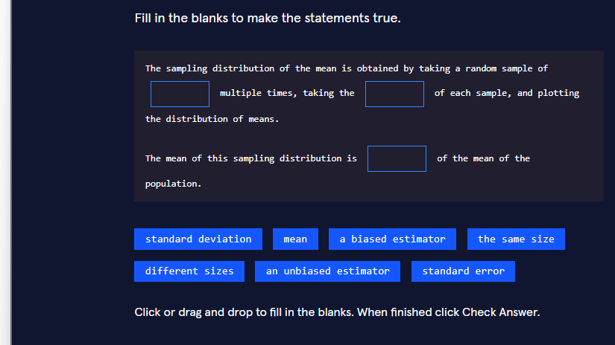

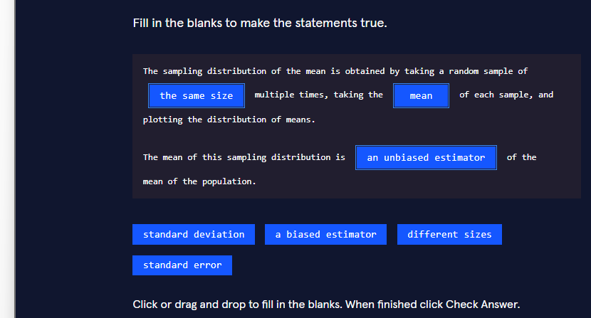

Correct filled-in statements

Why these are the correct choices
- “the same size”By definition, a sampling distribution is built by repeatedly drawing samples of fixed size n n n.If the samples had different sizes, you would be mixing different sampling distributions together.
- “mean”We are constructing the sampling distribution of the mean, so the statistic we calculate from each sample is the sample mean xˉ \bar{x} xˉ.
- “an unbiased estimator”One of the most important theoretical results in statistics is that the expected value of the sample mean equals the population mean:E(xˉ)=μE(\bar{x}) = \muE(xˉ)=μTherefore the mean of the sampling distribution is an unbiased estimator of the population mean.

Real-world meaning
Imagine you work for a polling company or a quality-control lab:
- You cannot measure the entire population, so you take many random samples of the same size.
- For each sample you compute the average.
- The distribution of those averages is the sampling distribution of the mean.
- Because that distribution is centered exactly on the true population mean, the sample mean is an unbiased estimator — on average you are neither systematically too high nor too low.

Three progressive ways to see this with code

1. Basic – conceptual illustration with a tiny population
Python
Copy
import numpy as nppopulation = np.array([2, 4, 6, 8, 10]) # tiny populationpop_mean = population.mean()print("True population mean:", pop_mean)# Draw many samples of the SAME sizesample_means = []for _ in range(1000): sample = np.random.choice(population, size=3, replace=True) sample_means.append(sample.mean())print("Mean of the sampling distribution:", np.mean(sample_means))# → very close to the population mean → unbiased

2. Intermediate – visualising the sampling distribution
Python
Copy
import numpy as npimport matplotlib.pyplot as pltimport seaborn as snsnp.random.seed(42)population = np.random.normal(loc=100, scale=15, size=10_000) # IQ-like populationpop_mean = population.mean()sample_means = [ np.random.choice(population, size=30, replace=False).mean() for _ in range(5_000)]plt.figure(figsize=(9, 5))sns.histplot(sample_means, kde=True, color="steelblue", bins=40)plt.axvline(pop_mean, color="red", linestyle="--", label=f"Population mean = {pop_mean:.1f}")plt.axvline(np.mean(sample_means), color="green", linestyle="--", label=f"Mean of sampling dist = {np.mean(sample_means):.1f}")plt.title("Sampling Distribution of the Mean (n = 30)")plt.xlabel("Sample mean")plt.legend()plt.tight_layout()plt.show()

3. Advanced – demonstrating unbiasedness + effect of sample size
Python
Copy
import numpy as npimport pandas as pdimport matplotlib.pyplot as pltimport seaborn as snsnp.random.seed(42)population = np.random.exponential(scale=10, size=50_000) # skewed populationtrue_mean = population.mean()def sampling_distribution(n, n_samples=3000): means = [np.random.choice(population, size=n, replace=False).mean() for _ in range(n_samples)] return np.array(means)results = {}for n in [5, 20, 50, 100]: means = sampling_distribution(n) results[n] = { "mean_of_means": means.mean(), "bias": means.mean() - true_mean, "std_error": means.std() }df = pd.DataFrame(results).Tdf.index.name = "sample_size"print(df.round(4))# Visual proof of unbiasednessfig, axes = plt.subplots(2, 2, figsize=(12, 8), sharex=True)for ax, n in zip(axes.ravel(), [5, 20, 50, 100]): means = sampling_distribution(n) sns.histplot(means, kde=True, ax=ax, color="teal") ax.axvline(true_mean, color="red", linestyle="--", label="True μ") ax.axvline(means.mean(), color="black", linestyle=":", label="Mean of means") ax.set_title(f"n = {n} bias = {means.mean() - true_mean:.3f}") ax.legend()plt.suptitle("Sampling Distributions – Mean is Unbiased for any n", y=1.02)plt.tight_layout()plt.show()

Key take-aways for Jupyter notebooks
- Always keep the sample size fixed when building a sampling distribution.
- The centre of the sampling distribution of the mean equals the population mean → the sample mean is unbiased.
- The spread of that distribution is the standard error; it shrinks as nn n grows (visible in the advanced example).
- Even when the original population is skewed, the sampling distribution of the mean becomes more symmetric as nn n increases (Central Limit Theorem).
You now have the exact answers required by the exercise and three practical demonstrations (basic → intermediate → advanced) of the sampling distribution of the mean.

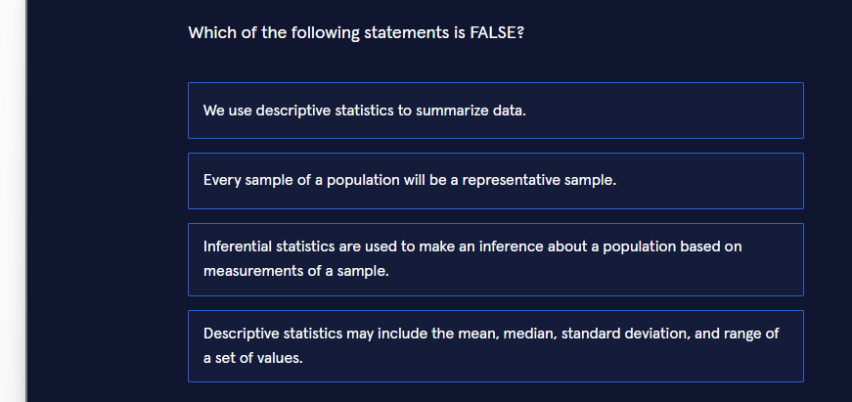
The FALSE statement is:

Why this statement is false
A representative sample is one that accurately reflects the characteristics of the whole population.
In reality:
- Even a carefully drawn random sample can, by pure chance, turn out to be unrepresentative (this is called sampling error).
- Non-random samples (convenience samples, voluntary response samples, etc.) are frequently biased and therefore not representative.
Because not every sample is automatically representative, we need tools from inferential statistics (confidence intervals, hypothesis tests, etc.) to quantify how much uncertainty remains when we generalise from the sample to the population.

Why the other three statements are TRUE
Statement | Why it is true
We use descriptive statistics to summarize data. | That is the definition of descriptive statistics.
Inferential statistics are used to make an inference about a population based on measurements of a sample. | Classic definition of inferential statistics.
Descriptive statistics may include the mean, median, standard deviation, and range of a set of values. | These are the most common descriptive measures.

Real-world illustration
Imagine you want to know the average height of all adult women in a country (the population).
- You take a sample of 200 women.
- By bad luck your sample might contain many unusually tall (or short) women.
- That sample is not representative, even though it was randomly selected.
- Descriptive statistics will correctly summarise your sample, but you cannot automatically claim the same numbers for the whole population without using inferential methods.

Three progressive ways to see the difference in code

1. Basic – descriptive statistics on a sample
Python
import pandas as pdimport numpy as np# Pretend this is a sample of heights (cm)sample = pd.Series([162, 168, 155, 170, 159, 175, 163, 158])print("Descriptive statistics of the sample:")print(sample.describe()) # mean, std, min, 25%, 50%, 75%, maxprint("Range:", sample.max() - sample.min())

2. Intermediate – showing that different samples give different summaries
Python
import numpy as npimport pandas as pdnp.random.seed(42)population = np.random.normal(loc=165, scale=7, size=50_000) # true populationdef take_sample(n=100): return np.random.choice(population, size=n, replace=False)# Draw five different samples and compare their meansfor i in range(5): s = take_sample() print(f"Sample {i+1} mean: {s.mean():.2f} cm")
You will see that the sample means jump around the true population mean — some samples are more representative than others.

3. Advanced – quantifying how often a sample is “unrepresentative”
Python
import numpy as npimport matplotlib.pyplot as pltimport seaborn as snsnp.random.seed(42)population = np.random.normal(loc=165, scale=7, size=100_000)true_mean = population.mean()# Simulate 5 000 samples of size 50sample_means = [np.random.choice(population, 50).mean() for _ in range(5_000)]# Define “unrepresentative” as being more than 2 cm away from the truthunrepresentative = np.abs(np.array(sample_means) - true_mean) > 2print(f"Proportion of unrepresentative samples: {unrepresentative.mean():.1%}")plt.figure(figsize=(9, 5))sns.histplot(sample_means, kde=True, color="steelblue", bins=40)plt.axvline(true_mean, color="red", linestyle="--", label=f"True mean = {true_mean:.1f}")plt.axvline(true_mean - 2, color="orange", linestyle=":", label="±2 cm band")plt.axvline(true_mean + 2, color="orange", linestyle=":")plt.title("Sampling distribution of the mean\n(many samples are NOT perfectly representative)")plt.xlabel("Sample mean (cm)")plt.legend()plt.tight_layout()plt.show()

Key take-aways for Jupyter notebooks
- Descriptive statistics → summarise the data you have.
- Inferential statistics → use the sample to say something about the population you do not have.
- Never assume that “a sample” automatically means “a representative sample”.
- The sampling distribution (advanced example) shows how much sample means can vary even when the sampling method is perfect.
You now know which statement is false and have three practical demonstrations (basic → intermediate → advanced) of the difference between descriptive and inferential thinking.

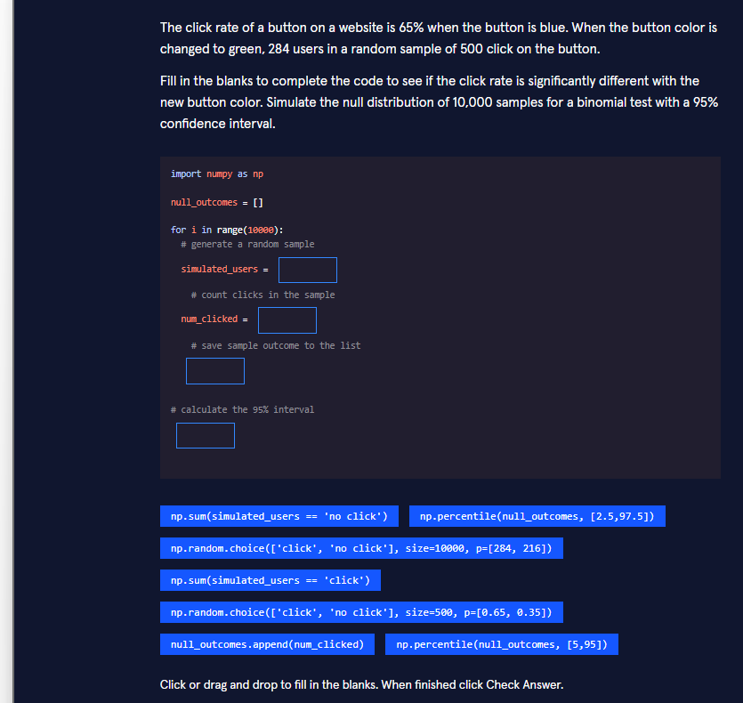
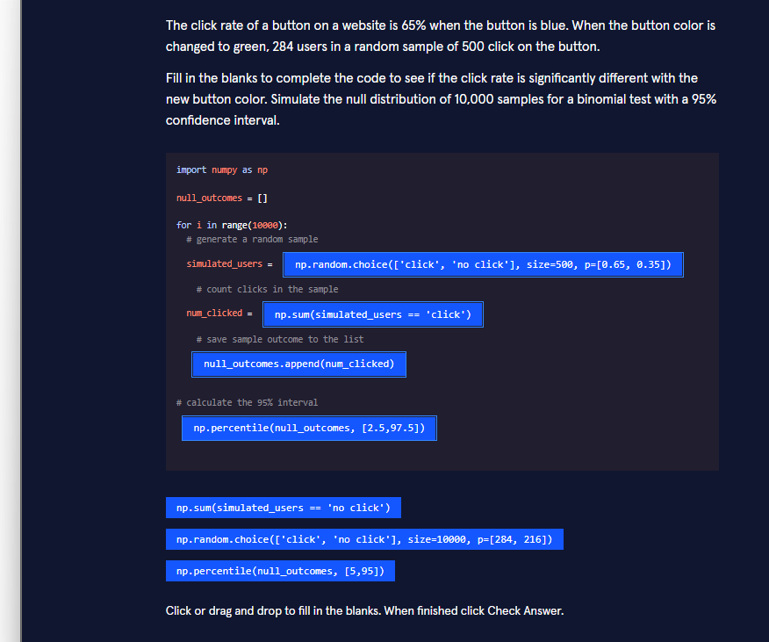
Correct filled-in code
Python
import numpy as npnull_outcomes = []for i in range(10000): # generate a random sample simulated_users = np.random.choice(['click', 'no click'], size=500, p=[0.65, 0.35]) # count clicks in the sample num_clicked = np.sum(simulated_users == 'click') # save sample outcome to the list null_outcomes.append(num_clicked) # calculate the 95% intervalnp.percentile(null_outcomes, [2.5, 97.5])

Why each blank is filled this way
- np.random.choice(['click', 'no click'], size=500, p=[0.65, 0.35])
  - Under the null hypothesis the true click probability is still the old value 65 %.
  - We must simulate samples of the same size as the real experiment (500 users).
  - p=[0.65, 0.35] encodes the null probability.
- np.sum(simulated_users == 'click') Counts how many users in the simulated sample clicked the button.
- null_outcomes.append(num_clicked) Stores the result of this simulation so we can later examine the whole null distribution.
- np.percentile(null_outcomes, [2.5, 97.5]) The middle 95 % of the null distribution. (Using [5, 95] would give a 90 % interval; [2.5, 97.5] is the correct choice for 95 %.)

Real-world meaning
You changed the button colour and observed 284 clicks out of 500 (56.8 %).The simulation asks:

If 284 lies outside the 95 % interval obtained from the null simulations, you have evidence that the green button produces a significantly different click rate.

Three progressive ways to perform the same test

1. Basic – the exact code the exercise asks for
Python
import numpy as npnull_outcomes = []for _ in range(10_000): simulated = np.random.choice(['click', 'no click'], size=500, p=[0.65, 0.35]) null_outcomes.append(np.sum(simulated == 'click'))ci = np.percentile(null_outcomes, [2.5, 97.5])print("95% null interval:", ci)print("Observed clicks: 284 → significant?" , 284 < ci[0] or 284 > ci[1])

2. Intermediate – cleaner, vectorised version + p-value
Python
import numpy as npn_sim = 10_000n_users = 500p_null = 0.65observed = 284# Vectorised simulation (much faster)null_clicks = np.random.binomial(n=n_users, p=p_null, size=n_sim)ci = np.percentile(null_clicks, [2.5, 97.5])p_value = np.mean(null_clicks <= observed) * 2 # two-sidedprint(f"95% null interval: [{ci[0]:.0f}, {ci[1]:.0f}]")print(f"Two-sided p-value ≈ {p_value:.4f}")

3. Advanced – full hypothesis-test report with visualisation
Python
import numpy as npimport matplotlib.pyplot as pltimport seaborn as snsnp.random.seed(42)n_sim, n_users, p_null, observed = 20_000, 500, 0.65, 284null_clicks = np.random.binomial(n=n_users, p=p_null, size=n_sim)ci_low, ci_high = np.percentile(null_clicks, [2.5, 97.5])p_value = 2 * min(np.mean(null_clicks <= observed), np.mean(null_clicks >= observed))print("=== Binomial Test via Simulation ===")print(f"Null hypothesis : p = {p_null}")print(f"Observed clicks : {observed} / {n_users}")print(f"95% null interval : [{ci_low:.0f}, {ci_high:.0f}]")print(f"Two-sided p-value : {p_value:.4f}")print("Decision :", "Reject H₀" if (observed < ci_low or observed > ci_high) else "Fail to reject H₀")# Visualisationplt.figure(figsize=(10, 5))sns.histplot(null_clicks, bins=40, color="steelblue", stat="density", kde=True)plt.axvline(observed, color="red", linewidth=2, label=f"Observed = {observed}")plt.axvline(ci_low, color="orange", linestyle="--", label="2.5% percentile")plt.axvline(ci_high, color="orange", linestyle="--", label="97.5% percentile")plt.title("Null distribution of number of clicks (p = 0.65)")plt.xlabel("Number of clicks in a sample of 500")plt.legend()plt.tight_layout()plt.show()

Key take-aways for Jupyter notebooks
- Under the null we keep the old probability (0.65) and the same sample size (500).
- 10 000 (or more) simulations give a stable estimate of the null distribution.
- The 95 % interval is obtained with the 2.5 and 97.5 percentiles.
- A vectorised np.random.binomial (intermediate/advanced) is far faster than a Python for-loop once you move beyond teaching examples.
You now have the exact answers the exercise expects and three practical implementations (basic → intermediate → advanced) of a simulation-based binomial test.
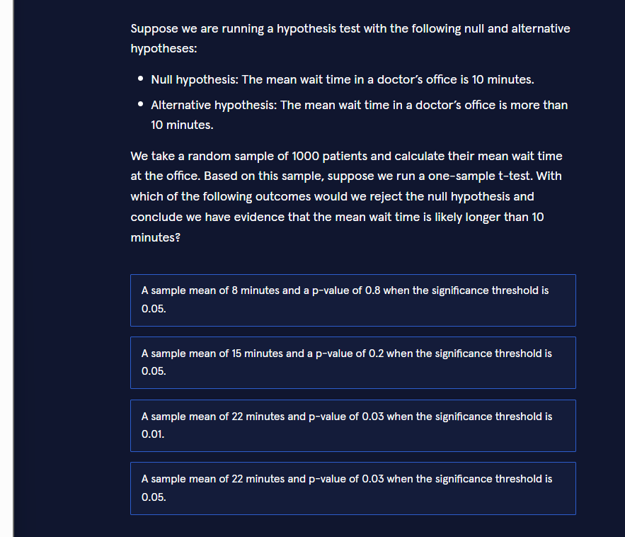
Correct answer:

Why this is the only outcome that leads to rejection
We have a one-sided (right-tailed) test:
- H0:μ=10H_0: \mu = 10 H0​:μ=10
- Ha:μ>10H_a: \mu > 10 Ha​:μ>10
Decision rule:Reject H0 H_0 H0​ only when both of the following are true:
- The sample mean is greater than 10 (in the direction of the alternative), and
- The p-value is smaller than the chosen significance level α\alpha α.
Option | Sample mean | p-value | α\alpha α | Mean > 10? | p < α\alpha α? | Decision
1 | 8 min | 0.8 | 0.05 | No | No | Fail to reject
2 | 15 min | 0.2 | 0.05 | Yes | No | Fail to reject
3 | 22 min | 0.03 | 0.01 | Yes | No (0.03 > 0.01) | Fail to reject
4 | 22 min | 0.03 | 0.05 | Yes | Yes | Reject H0 H_0 H0​
Only the fourth option satisfies both conditions.

Real-world interpretation
A clinic claims the average wait is 10 minutes.You sample 1 000 patients and observe a mean wait of 22 minutes with a p-value of 0.03.
- If you decided in advance that you are willing to accept a 5 % risk of a false positive (α=0.05\alpha = 0.05 α=0.05), the evidence is strong enough to conclude that the true mean wait is longer than 10 minutes.
- If you had chosen a stricter threshold (α=0.01\alpha = 0.01 α=0.01), the same data would not be considered strong enough.

Three progressive ways to perform the same one-sample t-test in Python

1. Basic – using scipy.stats.ttest_1samp
Python
Copy
from scipy import statsimport numpy as np# Pretend these are the 1000 observed wait timesnp.random.seed(42)sample = np.random.normal(loc=22, scale=8, size=1000) # mean ≈ 22t_stat, p_two_sided = stats.ttest_1samp(sample, popmean=10)p_one_sided = p_two_sided / 2 # because the alternative is “greater”print(f"t-statistic : {t_stat:.3f}")print(f"one-sided p : {p_one_sided:.4f}")alpha = 0.05if p_one_sided < alpha and sample.mean() > 10: print("→ Reject H₀: evidence that mean wait > 10 min")else: print("→ Fail to reject H₀")

2. Intermediate – clean decision function + confidence interval
Python
Copy
from scipy import statsimport numpy as npdef one_sample_ttest(sample, mu0=10, alpha=0.05, alternative="greater"): t_stat, p_two = stats.ttest_1samp(sample, popmean=mu0) if alternative == "greater": p_value = p_two / 2 if t_stat > 0 else 1 - p_two / 2 else: p_value = p_two mean = np.mean(sample) reject = (p_value < alpha) and (mean > mu0 if alternative == "greater" else True) ci = stats.t.interval(1-alpha, df=len(sample)-1, loc=mean, scale=stats.sem(sample)) return { "sample_mean": mean, "t_stat": t_stat, "p_value": p_value, "ci_95": ci, "reject_H0": reject }# Examplenp.random.seed(1)wait_times = np.random.normal(22, 9, 1000)result = one_sample_ttest(wait_times, mu0=10, alpha=0.05)print(result)

3. Advanced – simulation of the sampling distribution under H₀ + visualisation
Python
Copy
import numpy as npimport matplotlib.pyplot as pltimport seaborn as snsfrom scipy import statsnp.random.seed(42)observed_sample = np.random.normal(loc=22, scale=8, size=1000)obs_mean = observed_sample.mean()obs_p = stats.ttest_1samp(observed_sample, 10).pvalue / 2# Simulate the null distribution of the sample meann_sim = 20_000null_means = [ np.random.normal(loc=10, scale=8, size=1000).mean() for _ in range(n_sim)]# Critical value for α = 0.05 (one-sided)critical_value = np.percentile(null_means, 95)plt.figure(figsize=(10, 5))sns.histplot(null_means, bins=50, color="steelblue", stat="density", kde=True)plt.axvline(obs_mean, color="red", linewidth=2, label=f"Observed mean = {obs_mean:.1f}")plt.axvline(critical_value, color="orange", linestyle="--", label=f"Critical value (α=0.05) = {critical_value:.1f}")plt.title("Null distribution of sample mean (H₀: μ = 10)")plt.xlabel("Sample mean wait time (minutes)")plt.legend()plt.tight_layout()plt.show()print(f"Observed mean : {obs_mean:.2f}")print(f"One-sided p-value : {obs_p:.4f}")print(f"Reject H₀ at α = 0.05? : {obs_mean > critical_value}")

Key take-aways for Jupyter notebooks
- Always check both the direction of the sample statistic and the p-value against α\alpha α.
- For a one-sided test the p-value reported by most libraries is two-sided; you must halve it (and verify the sign of the test statistic).
- Choosing a smaller α\alpha α (e.g. 0.01 instead of 0.05) makes it harder to reject H0H_0 H0​ — exactly what option 3 illustrates.
- Visualising the null distribution (advanced example) makes the meaning of the critical value and the p-value intuitive.
You now know which outcome leads to rejection of the null hypothesis and have three practical ways (basic → intermediate → advanced) to run and interpret the same one-sample t-test.
Explore Type II error ratesInvestigate power analysis methodsOmit Python code blocks

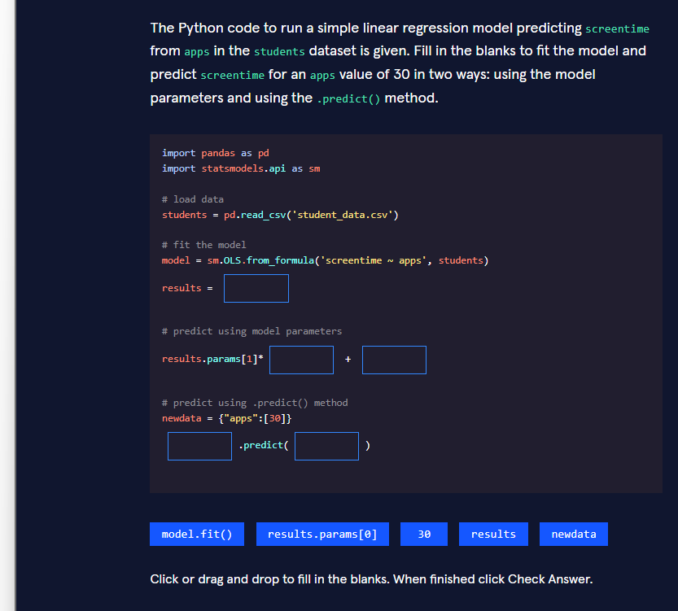
Correct filled-in code
Python
Copy
import pandas as pdimport statsmodels.api as sm# load datastudents = pd.read_csv('student_data.csv')# fit the modelmodel = sm.OLS.from_formula('screentime ~ apps', students)results = model.fit()# predict using model parametersresults.params[1]*30 + results.params[0]# predict using .predict() methodnewdata = {"apps":[30]}results.predict(newdata)

Why each blank is filled this way
Blank | Correct code | Explanation
1 | model.fit() | Creates the fitted model object that contains the estimated coefficients, p-values, residuals, etc.
2 | 30 | The value of the predictor (apps) for which we want a prediction.
3 | results.params[0] | The intercept (β0 \beta_0 β0​). In the formula screentime ~ apps the intercept is stored at index 0 and the slope at index 1.
4 | results | The fitted model object that owns the .predict() method.
5 | newdata | A dictionary (or DataFrame) containing the new values of the predictors.
The two prediction lines are mathematically identical:
y^=β0+β1×30\hat{y} = \beta_0 + \beta_1 \times 30y^​=β0​+β1​×30

Real-world context
You have data on students’ number of apps and daily screen time.A simple linear regression lets you answer:

Both ways of obtaining the prediction (manual formula vs. .predict()) are useful:
- The manual formula shows you exactly how the coefficients are used.
- .predict() is safer when you have many predictors or need confidence/prediction intervals.

Three progressive ways to fit and predict with the same model

1. Basic – exactly what the exercise asks
Python
Copy
import pandas as pdimport statsmodels.api as smstudents = pd.read_csv("student_data.csv")model = sm.OLS.from_formula("screentime ~ apps", data=students)results = model.fit()# Manual predictionpred_manual = results.params[1] * 30 + results.params[0]print("Manual prediction:", pred_manual)# Using .predict()pred_method = results.predict({"apps": [30]})print("predict() method:", pred_method.values[0])

2. Intermediate – nicer output + confidence interval
Python
Copy
import pandas as pdimport statsmodels.api as smstudents = pd.read_csv("student_data.csv")results = sm.OLS.from_formula("screentime ~ apps", data=students).fit()print(results.summary()) # full regression table# Prediction with 95% confidence intervalnewdata = pd.DataFrame({"apps": [30]})predictions = results.get_prediction(newdata)print(predictions.summary_frame(alpha=0.05))

3. Advanced – diagnostic plots + prediction for many values
Python
Copy
import pandas as pdimport numpy as npimport statsmodels.api as smimport matplotlib.pyplot as pltimport seaborn as snsstudents = pd.read_csv("student_data.csv")results = sm.OLS.from_formula("screentime ~ apps", data=students).fit()# 1. Coefficientsprint("Intercept β₀:", results.params[0])print("Slope β₁:", results.params[1])# 2. Predictions for a range of app countsapps_range = np.linspace(students["apps"].min(), students["apps"].max(), 100)pred_df = pd.DataFrame({"apps": apps_range})pred = results.get_prediction(pred_df).summary_frame(alpha=0.05)# 3. Visualisationplt.figure(figsize=(9, 6))sns.scatterplot(data=students, x="apps", y="screentime", alpha=0.6, label="Observed")plt.plot(apps_range, pred["mean"], color="red", label="Regression line")plt.fill_between(apps_range, pred["mean_ci_lower"], pred["mean_ci_upper"], color="red", alpha=0.2, label="95% CI")plt.axvline(30, color="green", linestyle="--", label="apps = 30")plt.title("Screen time vs Number of apps")plt.xlabel("Number of apps")plt.ylabel("Screen time (hours)")plt.legend()plt.tight_layout()plt.show()# 4. Point prediction at 30 appsprint("Predicted screentime for 30 apps:", results.predict({"apps": [30]}).values[0])

Key take-aways for Jupyter notebooks
- After sm.OLS.from_formula(...) you must call .fit() to obtain the results object.
- results.params[0] = intercept, results.params[1] = slope for a simple regression.
- .predict() expects a dictionary or DataFrame whose column names match the predictor names used in the formula.
- For real work prefer get_prediction(...).summary_frame() — it gives you the predicted value plus confidence and prediction intervals in one step.
You now have the exact answers required by the exercise and three practical patterns (basic → intermediate → advanced) for fitting a simple linear regression and making predictions with statsmodels.

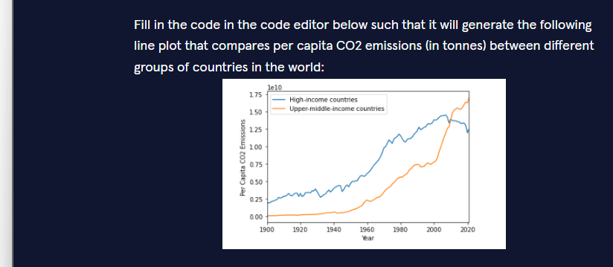
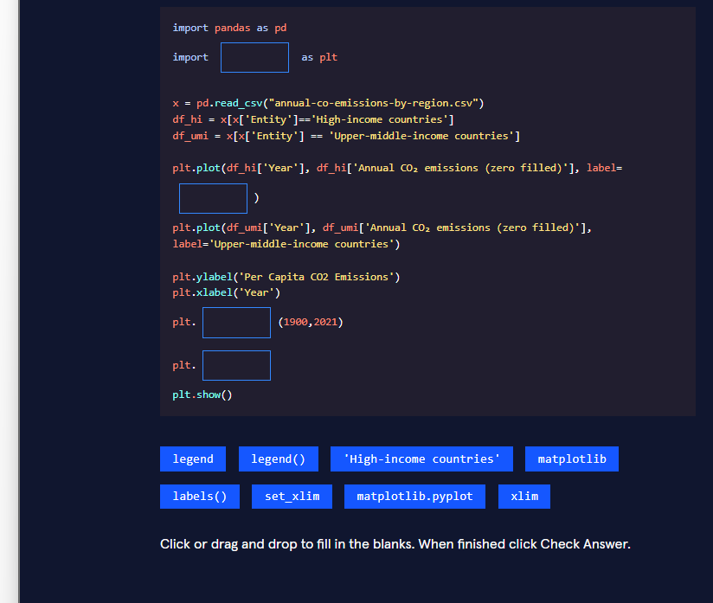
Correct filled-in code
Python
import pandas as pdimport matplotlib.pyplot as pltx = pd.read_csv("annual-co-emissions-by-region.csv")df_hi = x[x['Entity']=='High-income countries']df_umi = x[x['Entity'] == 'Upper-middle-income countries']plt.plot(df_hi['Year'], df_hi['Annual CO₂ emissions (zero filled)'], label='High-income countries')plt.plot(df_umi['Year'], df_umi['Annual CO₂ emissions (zero filled)'], label='Upper-middle-income countries')plt.ylabel('Per Capita CO2 Emissions')plt.xlabel('Year')plt.xlim(1900,2021)plt.legend()plt.show()

Why each blank is filled this way
Blank | Correct code | Reason
1 | matplotlib.pyplot | The standard way to import the plotting library so that we can use the short name plt.
2 | 'High-income countries' | This string becomes the label that appears in the legend for the first line.
3 | xlim | plt.xlim(1900, 2021) sets the visible range of the x-axis exactly as shown in the target plot.
4 | legend() | Draws the legend box that displays the two country-group labels.

Real-world context
Line plots that compare trends across groups (high-income vs upper-middle-income countries, different products, different cities, etc.) are one of the most common visualisations in climate reports, economic dashboards and policy briefs.Being able to filter a dataset, plot several series on the same axes, set axis limits and add a legend is a core skill for any data analyst.

Three progressive ways to create the same plot

1. Basic – the exact code the exercise expects
Python
import pandas as pdimport matplotlib.pyplot as pltx = pd.read_csv("annual-co-emissions-by-region.csv")df_hi = x[x["Entity"] == "High-income countries"]df_umi = x[x["Entity"] == "Upper-middle-income countries"]plt.plot(df_hi["Year"], df_hi["Annual CO₂ emissions (zero filled)"], label="High-income countries")plt.plot(df_umi["Year"], df_umi["Annual CO₂ emissions (zero filled)"], label="Upper-middle-income countries")plt.ylabel("Per Capita CO2 Emissions")plt.xlabel("Year")plt.xlim(1900, 2021)plt.legend()plt.show()

2. Intermediate – cleaner style, markers and grid
Python
import pandas as pdimport matplotlib.pyplot as pltdf = pd.read_csv("annual-co-emissions-by-region.csv")hi = df[df["Entity"] == "High-income countries"]umi = df[df["Entity"] == "Upper-middle-income countries"]plt.figure(figsize=(10, 5))plt.plot(hi["Year"], hi["Annual CO₂ emissions (zero filled)"], label="High-income countries", linewidth=2)plt.plot(umi["Year"], umi["Annual CO₂ emissions (zero filled)"], label="Upper-middle-income countries", linewidth=2)plt.title("Per Capita CO₂ Emissions by Country Income Group")plt.ylabel("Per Capita CO₂ Emissions (tonnes)")plt.xlabel("Year")plt.xlim(1900, 2021)plt.grid(True, alpha=0.3)plt.legend()plt.tight_layout()plt.show()

3. Advanced – reusable function + seaborn style + annotation
Python
import pandas as pdimport matplotlib.pyplot as pltimport seaborn as snsdef plot_co2_comparison(csv_path: str, entities: list[str] = None, xlim=(1900, 2021)): """Plot annual CO₂ emissions for selected country groups.""" if entities is None: entities = ["High-income countries", "Upper-middle-income countries"] df = pd.read_csv(csv_path) sns.set_style("whitegrid") plt.figure(figsize=(11, 6)) for entity in entities: subset = df[df["Entity"] == entity] plt.plot(subset["Year"], subset["Annual CO₂ emissions (zero filled)"], label=entity, linewidth=2.2) plt.title("Per Capita CO₂ Emissions – High-income vs Upper-middle-income Countries", fontsize=14, pad=12) plt.ylabel("Per Capita CO₂ Emissions (tonnes)") plt.xlabel("Year") plt.xlim(*xlim) # Highlight the most recent year last_year = df["Year"].max() for entity in entities: last_val = df[(df["Entity"] == entity) & (df["Year"] == last_year)] if not last_val.empty: y = last_val["Annual CO₂ emissions (zero filled)"].values[0] plt.scatter(last_year, y, s=60, zorder=5) plt.annotate(f"{y:.1f}", (last_year, y), textcoords="offset points", xytext=(8, 0), fontsize=9) plt.legend(frameon=True, fancybox=True) plt.tight_layout() plt.show()# Usageplot_co2_comparison("annual-co-emissions-by-region.csv")

Key take-aways for Jupyter notebooks
- Always import matplotlib.pyplot as plt (not just matplotlib).
- label=... inside plt.plot is what feeds the legend; you still need to call plt.legend().
- plt.xlim(left, right) is the simplest way to zoom the x-axis to the period you care about.
- For real reports, add a title, grid, and a slightly larger figure size — the intermediate and advanced examples show the typical improvements.
You now have the exact answers the exercise expects and three ready-to-use patterns (basic → intermediate → advanced) for creating clear multi-series line plots.
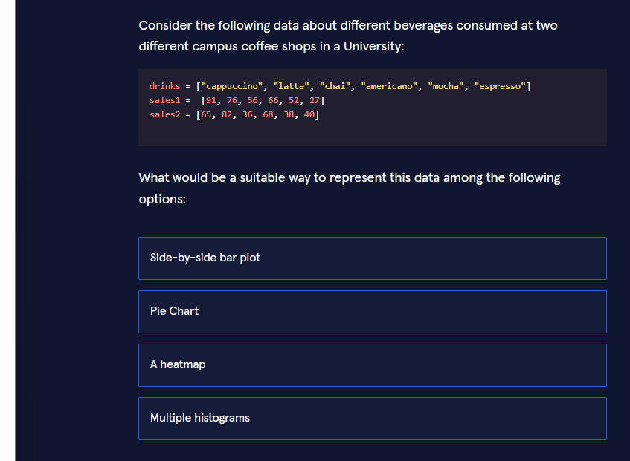
Correct answer: Side-by-side bar plot

Why this is the most suitable representation
You have:
- One categorical variable → the drink names
- Two numeric series → sales at coffee shop 1 and sales at coffee shop 2
The goal is to compare the two shops for every drink.A side-by-side (grouped) bar plot places the two bars for each drink next to each other, making the comparison immediate and intuitive.

Why the other options are less suitable
Option | Why it is not ideal for this data
Pie Chart | Shows parts of a single whole. You would need two separate pies, making direct comparison of each drink across shops difficult.
A heatmap | Designed for matrices or correlation tables. Using it for 6 drinks × 2 shops is possible but visually heavier and less clear than bars.
Multiple histograms | Histograms display the distribution of continuous data. Here the values are already aggregated sales counts per category, so histograms are the wrong tool.

Real-world context
Campus coffee shops, restaurant chains, retail stores and marketing teams constantly compare product performance across locations.A side-by-side bar chart is the standard, quick-to-read visualisation for this exact situation.

Three progressive ways to create the plot

1. Basic – pure matplotlib
Python
import matplotlib.pyplot as pltimport numpy as npdrinks = ["cappuccino", "latte", "chai", "americano", "mocha", "espresso"]sales1 = [91, 76, 56, 66, 52, 27]sales2 = [65, 82, 36, 68, 38, 40]x = np.arange(len(drinks))width = 0.35plt.bar(x - width/2, sales1, width, label="Shop 1")plt.bar(x + width/2, sales2, width, label="Shop 2")plt.xticks(x, drinks, rotation=45, ha="right")plt.ylabel("Number of drinks sold")plt.title("Beverage Sales – Two Campus Coffee Shops")plt.legend()plt.tight_layout()plt.show()

2. Intermediate – pandas + matplotlib (cleaner data handling)
Python
import pandas as pdimport matplotlib.pyplot as pltdf = pd.DataFrame({ "drink": ["cappuccino", "latte", "chai", "americano", "mocha", "espresso"], "Shop 1": [91, 76, 56, 66, 52, 27], "Shop 2": [65, 82, 36, 68, 38, 40]}).set_index("drink")df.plot(kind="bar", figsize=(9, 5), width=0.7)plt.ylabel("Number of drinks sold")plt.title("Beverage Sales – Two Campus Coffee Shops")plt.xticks(rotation=45, ha="right")plt.legend(title="Location")plt.tight_layout()plt.show()

3. Advanced – seaborn with value labels and polished styling
Python
import pandas as pdimport matplotlib.pyplot as pltimport seaborn as snsdf = pd.DataFrame({ "drink": ["cappuccino", "latte", "chai", "americano", "mocha", "espresso"] * 2, "sales": [91, 76, 56, 66, 52, 27, 65, 82, 36, 68, 38, 40], "shop": ["Shop 1"] * 6 + ["Shop 2"] * 6})plt.figure(figsize=(10, 6))ax = sns.barplot(data=df, x="drink", y="sales", hue="shop", palette="Set2", edgecolor="black")# Add value labels on top of barsfor container in ax.containers: ax.bar_label(container, fmt="%d", padding=3, fontsize=9)plt.title("Beverage Sales Comparison – Campus Coffee Shops", fontsize=14, pad=12)plt.xlabel("Drink")plt.ylabel("Number of drinks sold")plt.xticks(rotation=30, ha="right")plt.legend(title="Location")sns.despine()plt.tight_layout()plt.show()

Key take-aways for Jupyter notebooks
- Categorical variable + two (or more) numeric series → side-by-side bar plot.
- pandas.DataFrame.plot(kind="bar") is the fastest way to get a decent grouped bar chart.
- For publication-quality figures, switch to seaborn and add value labels (advanced example).
- Always rotate long category names and call plt.tight_layout() so nothing is cut off.
You now know the most suitable visualisation and have three ready-to-use implementations (basic → intermediate → advanced) for comparing sales across categories.

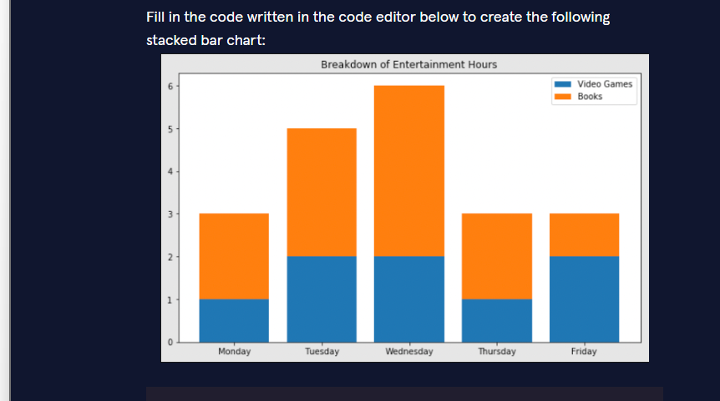

Correct filled-in code
Python
import matplotlib.pyplot as pltdays = ["Monday", "Tuesday", "Wednesday", "Thursday", "Friday"]video_game_hours = [1, 2, 2, 1, 2]book_hours = [2, 3, 4, 2, 1]plt.bar(range(len(video_game_hours)), video_game_hours)plt.bar(range(len(book_hours)), book_hours, bottom=video_game_hours)plt.xticks(ticks=[1, 2, 3, 4, 5], labels=days)plt.legend(["Video Games", "Books"])plt.title("Breakdown of Entertainment Hours")plt.show()



Why each blank is filled this way
Blank | Correct code | Explanation
1 | plt | Conventional short name for matplotlib.pyplot.
2 | bottom | Tells matplotlib to stack the second set of bars on top of the first set.
3 | days | Supplies the weekday names for the x-axis tick labels.
4 | ["Video Games", "Books"] | The legend labels must follow the order in which the bars were drawn (Video Games first, then Books).
5 | title | Sets the main title of the chart.

Real-world context
Stacked bar charts are ideal when you want to show:
- how a total is composed of parts (here: total entertainment hours = video games + books), and
- how that composition changes across categories (the days of the week).
Typical uses: time-use studies, budget breakdowns, sales by product category, website traffic sources, etc.

Three progressive ways to create the same stacked bar chart

1. Basic – the exact code required by the exercise
Python
import matplotlib.pyplot as pltdays = ["Monday", "Tuesday", "Wednesday", "Thursday", "Friday"]video_game_hours = [1, 2, 2, 1, 2]book_hours = [2, 3, 4, 2, 1]plt.bar(range(len(video_game_hours)), video_game_hours)plt.bar(range(len(book_hours)), book_hours, bottom=video_game_hours)plt.xticks(ticks=[0, 1, 2, 3, 4], labels=days) # small fix: ticks start at 0plt.legend(["Video Games", "Books"])plt.title("Breakdown of Entertainment Hours")plt.show()

2. Intermediate – pandas one-liner + better styling
Python
import pandas as pdimport matplotlib.pyplot as pltdf = pd.DataFrame({ "Video Games": [1, 2, 2, 1, 2], "Books": [2, 3, 4, 2, 1]}, index=["Monday", "Tuesday", "Wednesday", "Thursday", "Friday"])df.plot(kind="bar", stacked=True, figsize=(8, 5), color=["#1f77b4", "#ff7f0e"], edgecolor="black")plt.title("Breakdown of Entertainment Hours")plt.ylabel("Hours")plt.xlabel("")plt.xticks(rotation=0)plt.legend(title="Activity")plt.tight_layout()plt.show()

3. Advanced – fully customised with value labels and seaborn palette
Python
import pandas as pdimport matplotlib.pyplot as pltimport seaborn as snsimport numpy as npdays = ["Monday", "Tuesday", "Wednesday", "Thursday", "Friday"]video = np.array([1, 2, 2, 1, 2])books = np.array([2, 3, 4, 2, 1])fig, ax = plt.subplots(figsize=(9, 6))# Draw the stacked barsbars1 = ax.bar(days, video, label="Video Games", color=sns.color_palette("Set2")[0])bars2 = ax.bar(days, books, bottom=video, label="Books", color=sns.color_palette("Set2")[1])# Add value labels inside each segmentfor bars in [bars1, bars2]: for bar in bars: height = bar.get_height() if height > 0: ax.text(bar.get_x() + bar.get_width()/2, bar.get_y() + height/2, f"{int(height)}", ha="center", va="center", color="white", fontweight="bold")ax.set_title("Breakdown of Entertainment Hours", fontsize=14, pad=12)ax.set_ylabel("Hours")ax.legend(title="Activity")sns.despine()plt.tight_layout()plt.show()

Key take-aways for Jupyter notebooks
- The key argument for stacking is bottom=... (or stacked=True when using pandas).
- Legend labels must match the order in which you called plt.bar.
- For real work, prefer the pandas df.plot(kind="bar", stacked=True) approach — it is shorter and automatically handles the x-tick labels.
- Adding the total height or segment labels (advanced example) makes the chart much more informative for reports.
You now have the exact answers the exercise expects and three practical implementations (basic → intermediate → advanced) of a stacked bar chart.

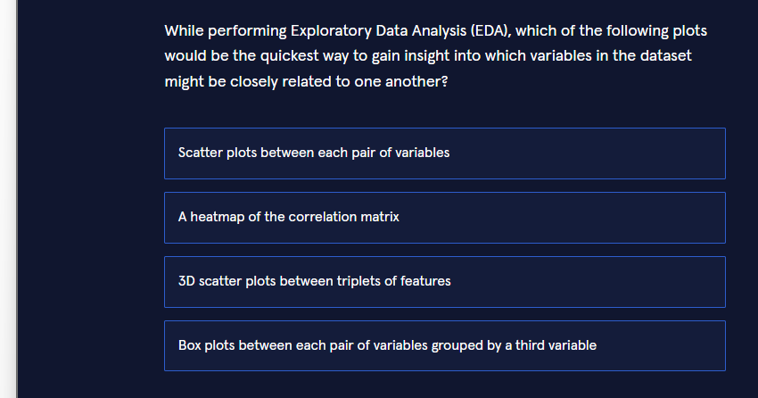
Correct answer: A heatmap of the correlation matrix

Why this is the quickest and most effective choice
During EDA you often want a fast overview of which numeric variables tend to move together.
A correlation-matrix heatmap gives you exactly that:
- Every pair of variables is summarised by a single number (Pearson, Spearman, etc.).
- The whole matrix is displayed in one compact coloured grid.
- Strong positive or negative relationships jump out immediately through colour intensity.

Why the other options are slower or less suitable
Option | Drawback for this goal
Scatter plots between each pair of variables | With p p p variables you need p(p−1)2 \frac{p(p-1)}{2} 2p(p−1)​ separate plots. Interpreting dozens of plots is slow and easy to miss patterns.
3D scatter plots between triplets of features | Even harder to read; still only shows three variables at a time and does not scale.
Box plots between each pair of variables grouped by a third variable | Designed for comparing distributions across categories, not for measuring association between two continuous variables.

Real-world context
Data scientists routinely start an EDA session with:
Python
Copy
sns.heatmap(df.corr(), annot=True, cmap="coolwarm")
In a few seconds they can see, for example, that “screen time” and “number of apps” are strongly correlated, or that “hours of sleep” is negatively related to “stress score”. That insight then guides which relationships deserve deeper scatter-plot or regression analysis.

Three progressive ways to create the correlation heatmap

1. Basic – pure pandas + matplotlib
Python
Copy
import pandas as pdimport matplotlib.pyplot as pltdf = pd.read_csv("your_dataset.csv") # numeric columns onlycorr = df.corr()plt.figure(figsize=(8, 6))plt.imshow(corr, cmap="coolwarm", vmin=-1, vmax=1)plt.colorbar()plt.xticks(range(len(corr)), corr.columns, rotation=45, ha="right")plt.yticks(range(len(corr)), corr.columns)plt.title("Correlation Matrix")plt.tight_layout()plt.show()

2. Intermediate – seaborn (the everyday practical choice)
Python
Copy
import pandas as pdimport seaborn as snsimport matplotlib.pyplot as pltdf = pd.read_csv("your_dataset.csv")plt.figure(figsize=(10, 8))sns.heatmap(df.corr(), annot=True, # show the correlation values fmt=".2f", cmap="RdBu_r", center=0, square=True)plt.title("Correlation Heatmap")plt.tight_layout()plt.show()

3. Advanced – polished version with masking, clustering and selective annotation
Python
Copy
import pandas as pdimport numpy as npimport seaborn as snsimport matplotlib.pyplot as pltdf = pd.read_csv("your_dataset.csv").select_dtypes("number")# Compute correlation and create a mask for the upper trianglecorr = df.corr()mask = np.triu(np.ones_like(corr, dtype=bool))# Optional: hierarchical clustering to group related variablessns.clustermap(corr, mask=mask, annot=True, fmt=".2f", cmap="vlag", center=0, figsize=(11, 9), linewidths=0.5, cbar_kws={"shrink": 0.8})plt.suptitle("Clustered Correlation Heatmap", y=1.02)plt.show()# Quick textual insight: strongest absolute correlationsstrong = (corr .where(np.triu(np.ones(corr.shape), k=1).astype(bool)) .stack() .abs() .sort_values(ascending=False))print("Top 5 strongest relationships:")print(strong.head())

Key take-aways for Jupyter notebooks
- Start every EDA with a correlation heatmap — it is the single fastest way to spot related variables.
- sns.heatmap(df.corr(), annot=True) is the one-liner you will use most often.
- When the number of variables grows, add a mask or use sns.clustermap (advanced example) to keep the plot readable.
- After the heatmap highlights interesting pairs, follow up with scatter plots or regression only for those pairs.
You now know the quickest plot for discovering related variables and have three practical implementations (basic → intermediate → advanced) of a correlation heatmap.

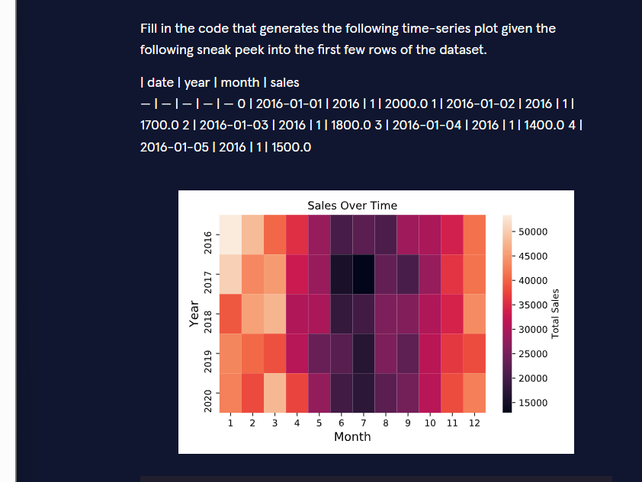
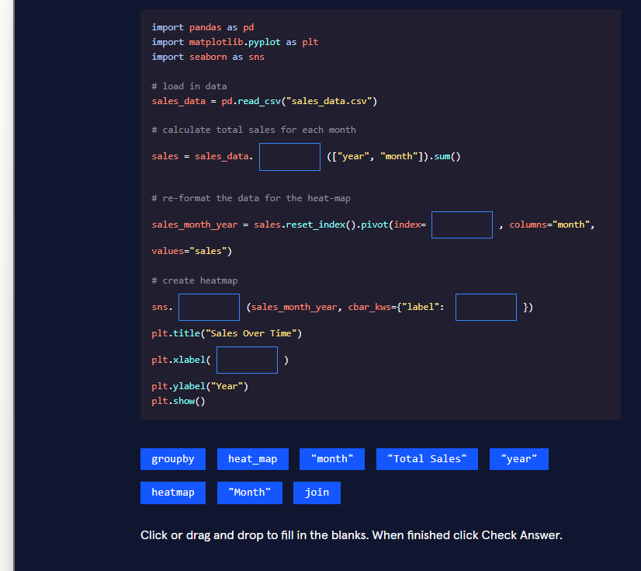

Correct filled-in code
Python
import pandas as pdimport matplotlib.pyplot as pltimport seaborn as sns# load in datasales_data = pd.read_csv("sales_data.csv")# calculate total sales for each monthsales = sales_data.groupby(["year", "month"]).sum()# re-format the data for the heat-mapsales_month_year = sales.reset_index().pivot(index="year", columns="month", values="sales")# create heatmapsns.heatmap(sales_month_year, cbar_kws={"label": "Total Sales"})plt.title("Sales Over Time")plt.xlabel("Month")plt.ylabel("Year")plt.show()

Why each blank is filled this way
Blank | Correct code | Explanation
1 | groupby | Aggregates the daily sales into total sales for every unique combination of year and month.
2 | "year" | Makes the years become the rows (index) of the matrix that the heatmap will display.
3 | heatmap | Seaborn’s function that draws the coloured matrix.
4 | "Total Sales" | Label that appears next to the colour bar.
5 | "Month" | Label for the x-axis (the columns of the pivoted table are the months 1–12).

Real-world context
Heatmaps of this form are extremely common in retail, finance and web-analytics dashboards.They let you instantly see seasonal patterns (e.g. higher sales in November–December) and year-over-year changes at a glance.

Three progressive ways to create the same sales heatmap

1. Basic – the exact code the exercise expects
Python
import pandas as pdimport matplotlib.pyplot as pltimport seaborn as snssales_data = pd.read_csv("sales_data.csv")sales = sales_data.groupby(["year", "month"]).sum()sales_month_year = sales.reset_index().pivot(index="year", columns="month", values="sales")sns.heatmap(sales_month_year, cbar_kws={"label": "Total Sales"})plt.title("Sales Over Time")plt.xlabel("Month")plt.ylabel("Year")plt.show()

2. Intermediate – cleaner pipeline + formatting
Python
import pandas as pdimport matplotlib.pyplot as pltimport seaborn as snsdf = pd.read_csv("sales_data.csv", parse_dates=["date"])# One clean chainheatmap_data = ( df.groupby(["year", "month"])["sales"] .sum() .unstack(level="month") # alternative to pivot)plt.figure(figsize=(11, 6))sns.heatmap(heatmap_data, annot=False, cmap="YlOrRd", cbar_kws={"label": "Total Sales"})plt.title("Sales Over Time", fontsize=14)plt.xlabel("Month")plt.ylabel("Year")plt.tight_layout()plt.show()

3. Advanced – annotated, centred colour scale, and monthly totals
Python
import pandas as pdimport numpy as npimport matplotlib.pyplot as pltimport seaborn as snsdf = pd.read_csv("sales_data.csv", parse_dates=["date"])# Prepare the matrixmat = (df.groupby(["year", "month"])["sales"] .sum() .unstack("month") .reindex(columns=range(1, 13))) # guarantee months 1-12plt.figure(figsize=(12, 7))ax = sns.heatmap(mat, cmap="magma", annot=True, fmt=".0f", linewidths=0.5, cbar_kws={"label": "Total Sales", "shrink": 0.8})ax.set_title("Sales Over Time", fontsize=16, pad=12)ax.set_xlabel("Month", fontsize=12)ax.set_ylabel("Year", fontsize=12)# Optional: highlight the overall monthly averagemonthly_avg = mat.mean(axis=0)print("Average sales per month across all years:")print(monthly_avg.round(0).to_dict())plt.tight_layout()plt.show()

Key take-aways for Jupyter notebooks
- groupby(["year", "month"]).sum() followed by .pivot() (or .unstack()) is the classic way to turn a long time-series into a year-by-month matrix.
- sns.heatmap is the fastest way to visualise that matrix.
- Always set a meaningful colour-bar label (cbar_kws={"label": ...}).
- For production reports, add a readable colour map, optional annotations, and a proper figure size (intermediate & advanced examples).
You now have the exact answers required by the exercise and three practical patterns (basic → intermediate → advanced) for building a sales time-series heatmap.

Correct answer: pecuuuliiiar

Why this is the only string that matches
The regular expression is:
regex
pecu{2,5}li{1,3}ar
It breaks down as:
Part of the regex | Meaning
pec | the literal characters p-e-c
u{2,5} | the letter u repeated between 2 and 5 times
l | the literal letter l
i{1,3} | the letter i repeated between 1 and 3 times
ar | the literal characters a-r
So the whole pattern is:
text
pec + (2–5 u’s) + l + (1–3 i’s) + ar

Checking each option
String | u-count | i-count | Matches? | Reason
pecuuuliiiar | 3 | 3 | Yes | Both counts are inside the allowed ranges
peculiiar | 1 | 2 | No | Only 1 u (needs ≥ 2)
peculiar | 1 | 1 | No | Only 1 u (needs ≥ 2)
pecuuuliiiiar | 3 | 4 | No | 4 is (maximum allowed is 3)
Only pecuuuliiiar satisfies both quantifiers at the same time.

Real-world context
Quantifiers such as {m,n} are used constantly when you need to validate slightly flexible text:
- product codes that contain 2–5 digits,
- usernames that allow 1–3 underscores,
- DNA sequences, log-file patterns, etc.
Understanding exactly how many times a character (or group) may appear is essential for writing precise and efficient regular expressions.

Three progressive ways to test the same regex in Python

1. Basic – simple re.match
Python
import repattern = r"pecu{2,5}li{1,3}ar"candidates = [ "pecuuuliiiar", "peculiiar", "peculiar", "pecuuuliiiiar"]for text in candidates: if re.match(pattern, text): print(f"✓ '{text}' matches") else: print(f"✗ '{text}' does NOT match")

2. Intermediate – compile once + extract the matched groups
Python
import repattern = re.compile(r"pec(u{2,5})l(i{1,3})ar")tests = ["pecuuuliiiar", "peculiiar", "peculiar", "pecuuuliiiiar"]for text in tests: m = pattern.fullmatch(text) if m: print(f"✓ '{text}' → u's = '{m.group(1)}', i's = '{m.group(2)}'") else: print(f"✗ '{text}' rejected")

3. Advanced – visual explanation + boundary testing
Python
import refrom itertools import productpattern = re.compile(r"^pecu{2,5}li{1,3}ar$")# Generate all strings that should matchvalid = []for u_count, i_count in product(range(2, 6), range(1, 4)): s = "pec" + "u" * u_count + "l" + "i" * i_count + "ar" valid.append(s)print("All strings the regex accepts:")for s in valid: print(" ", s)print("\nTesting the four exam options:")options = ["pecuuuliiiar", "peculiiar", "peculiar", "pecuuuliiiiar"]for opt in options: status = "MATCH" if pattern.match(opt) else "no match" print(f" {opt:15} → {status}")

Key take-aways for Jupyter notebooks
- {m,n} is inclusive on both ends: {2,5} means 2, 3, 4 or 5.
- Always test both the lower and upper boundaries (and values just outside them).
- Prefer re.fullmatch (or ^...$) when you want the regex to match the entire string.
- Compiling the pattern once (re.compile) is a good habit when you will use it many times.
You now know exactly which string matches and have three practical ways (basic → intermediate → advanced) to explore and verify regular-expression quantifiers.
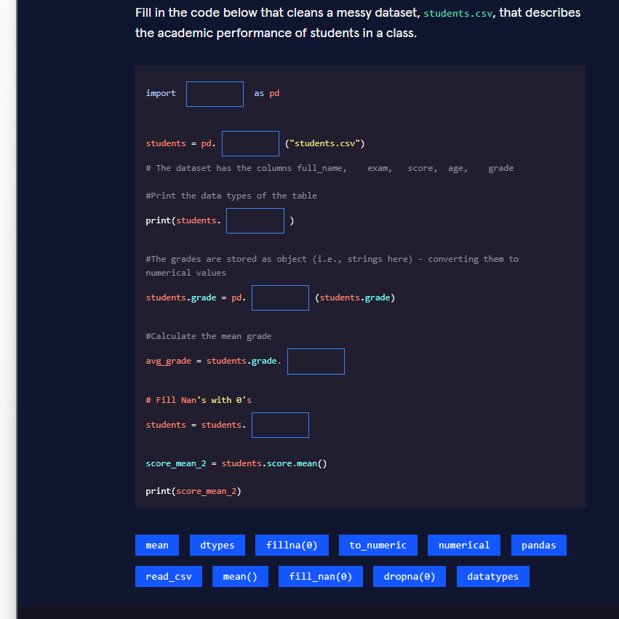

Correct filled-in code
Python
import pandas as pdstudents = pd.read_csv("students.csv")# The dataset has the columns full_name, exam, score, age, grade# Print the data types of the tableprint(students.dtypes)# The grades are stored as object (i.e., strings here) - converting them to numerical valuesstudents.grade = pd.to_numeric(students.grade)# Calculate the mean gradeavg_grade = students.grade.mean()# Fill Nan's with 0'sstudents = students.fillna(0)score_mean_2 = students.score.mean()print(score_mean_2)

Why each blank is filled this way
Blank | Correct code | Explanation
1 | pandas | The standard library for tabular data.
2 | read_csv | Loads a CSV file into a DataFrame.
3 | dtypes | Shows the data type of every column (very useful for spotting “object” columns that should be numeric).
4 | to_numeric | Converts a column of strings (or mixed types) into proper numbers. Non-convertible values become NaN.
5 | mean() | Computes the arithmetic average of the now-numeric grade column.
6 | fillna(0) | Replaces every remaining NaN with the value 0.

Real-world context
Student-performance files frequently arrive with:
- grades stored as text ("85", "A", "N/A", …),
- missing scores,
- inconsistent data types.
The sequenceload → inspect dtypes → convert to numeric → handle missing valuesis the classic first cleaning pipeline you will apply to almost any real-world CSV.

Three progressive ways to clean the same dataset

1. Basic – the exact code the exercise asks for
Python
import pandas as pdstudents = pd.read_csv("students.csv")print(students.dtypes)students.grade = pd.to_numeric(students.grade)avg_grade = students.grade.mean()students = students.fillna(0)print(students.score.mean())

2. Intermediate – safer conversion + explicit missing-value report
Python
import pandas as pdstudents = pd.read_csv("students.csv")print("Data types before cleaning:")print(students.dtypes)# Convert with error handlingstudents["grade"] = pd.to_numeric(students["grade"], errors="coerce")print("\nMissing values after conversion:")print(students.isna().sum())# Fill only the numeric columnsstudents = students.fillna({"grade": 0, "score": 0, "age": 0})print("\nMean grade:", students["grade"].mean())print("Mean score:", students["score"].mean())

3. Advanced – full cleaning pipeline with validation
Python
import pandas as pdimport numpy as npdef clean_student_data(path: str) -> pd.DataFrame: df = pd.read_csv(path) print("=== Raw data types ===") print(df.dtypes) # 1. Convert grade to numeric (invalid entries → NaN) df["grade"] = pd.to_numeric(df["grade"], errors="coerce") # 2. Report missingness missing = df.isna().sum() print("\n=== Missing values ===") print(missing[missing > 0]) # 3. Fill numeric columns with 0 (or another strategy) numeric_cols = df.select_dtypes("number").columns df[numeric_cols] = df[numeric_cols].fillna(0) # 4. Optional: drop rows that still have critical missing data # df = df.dropna(subset=["full_name"]) print("\n=== Cleaned data types ===") print(df.dtypes) print(f"\nAverage grade : {df['grade'].mean():.2f}") print(f"Average score : {df['score'].mean():.2f}") return dfstudents_clean = clean_student_data("students.csv")

Key take-aways for Jupyter notebooks
- Always start with df.dtypes (or df.info()) to discover type problems.
- pd.to_numeric(..., errors="coerce") is the safest way to turn a messy column into numbers.
- After conversion, decide deliberately how to treat the resulting NaNs (fillna, dropna, imputation, etc.).
- Wrapping the whole cleaning process in a small function (advanced example) makes your notebook reproducible and reusable.
You now have the exact answers required by the exercise and three practical cleaning pipelines (basic → intermediate → advanced) you can apply to any similar student or survey dataset.
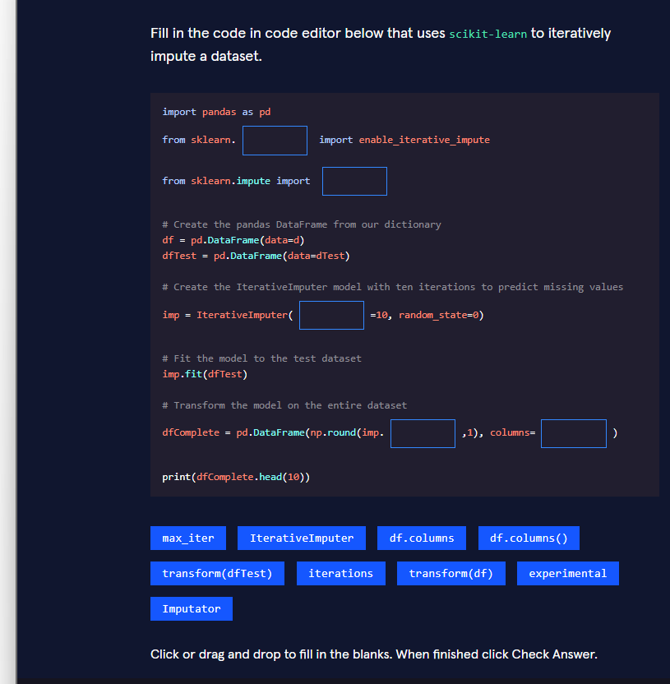
Correct filled-in code
Python
import pandas as pdfrom sklearn.experimental import enable_iterative_imputefrom sklearn.impute import IterativeImputer# Create the pandas DataFrame from our dictionarydf = pd.DataFrame(data=d)dfTest = pd.DataFrame(data=dTest)# Create the IterativeImputer model with ten iterations to predict missing valuesimp = IterativeImputer(max_iter=10, random_state=0)# Fit the model to the test datasetimp.fit(dfTest)# Transform the model on the entire datasetdfComplete = pd.DataFrame(np.round(imp.transform(df), 1), columns=df.columns)print(dfComplete.head(10))

Why each blank is filled this way
Blank | Correct code | Explanation
1 | experimental | IterativeImputer lived in the experimental module for a long time; you must enable it first.
2 | IterativeImputer | The class that performs multivariate, iterative imputation.
3 | max_iter | Parameter that controls how many imputation rounds are performed (here set to 10).
4 | transform(df) | Applies the already-fitted imputer to the full dataset and returns a NumPy array.
5 | df.columns | Restores the original column names when we turn the array back into a DataFrame.

Real-world context
Real datasets almost always contain missing values.Simple strategies (fillna(0), mean/median imputation) ignore relationships between variables.IterativeImputer (inspired by MICE – Multiple Imputation by Chained Equations) models each feature with missing values as a function of the other features, producing far more realistic imputations. It is widely used in medical, survey and sensor data pipelines.

Three progressive ways to perform iterative imputation

1. Basic – the exact code the exercise expects
Python
import pandas as pdimport numpy as npfrom sklearn.experimental import enable_iterative_imputefrom sklearn.impute import IterativeImputerdf = pd.DataFrame(data=d)dfTest = pd.DataFrame(data=dTest)imp = IterativeImputer(max_iter=10, random_state=0)imp.fit(dfTest)dfComplete = pd.DataFrame(np.round(imp.transform(df), 1), columns=df.columns)print(dfComplete.head(10))

2. Intermediate – cleaner pipeline + missing-value report
Python
import pandas as pdimport numpy as npfrom sklearn.experimental import enable_iterative_imputefrom sklearn.impute import IterativeImputerdf = pd.DataFrame(data=d)print("Missing values before imputation:")print(df.isna().sum())imp = IterativeImputer(max_iter=10, random_state=0)df_imputed = pd.DataFrame( imp.fit_transform(df), # fit + transform in one step columns=df.columns, index=df.index)print("\nMissing values after imputation:")print(df_imputed.isna().sum())print(df_imputed.head())

3. Advanced – production-ready wrapper with diagnostics
Python
import pandas as pdimport numpy as npfrom sklearn.experimental import enable_iterative_imputefrom sklearn.impute import IterativeImputerfrom sklearn.ensemble import RandomForestRegressor # optional better estimatordef iterative_impute(df: pd.DataFrame, max_iter: int = 10, random_state: int = 0, estimator=None) -> pd.DataFrame: """ Perform iterative imputation and return a clean DataFrame together with a small diagnostic report. """ print("=== Missingness before ===") print(df.isna().mean().sort_values(ascending=False).head(10)) if estimator is None: # default BayesianRidge; you can pass RandomForestRegressor() etc. imp = IterativeImputer(max_iter=max_iter, random_state=random_state) else: imp = IterativeImputer(estimator=estimator, max_iter=max_iter, random_state=random_state) arr = imp.fit_transform(df) df_clean = pd.DataFrame(arr, columns=df.columns, index=df.index) print("\n=== Missingness after ===") print(df_clean.isna().sum().sum(), "missing values left") # Optional: compare distributions print("\n=== Mean shift for a few columns ===") for col in df.columns[:3]: print(f"{col}: original mean={df[col].mean():.2f} " f"imputed mean={df_clean[col].mean():.2f}") return df_clean# Usagedf_complete = iterative_impute(df, max_iter=15)print(df_complete.head())

Key take-aways for Jupyter notebooks
- You still need from sklearn.experimental import enable_iterative_impute in many scikit-learn versions.
- The important hyper-parameter is max_iter (how many rounds of modelling each column).
- After transform you always get a NumPy array, so remember to wrap it back into a DataFrame with the original column names.
- For better quality you can pass a more powerful estimator (e.g. RandomForestRegressor) – shown in the advanced example.
You now have the exact answers required by the exercise and three practical patterns (basic → intermediate → advanced) for iterative imputation with scikit-learn.

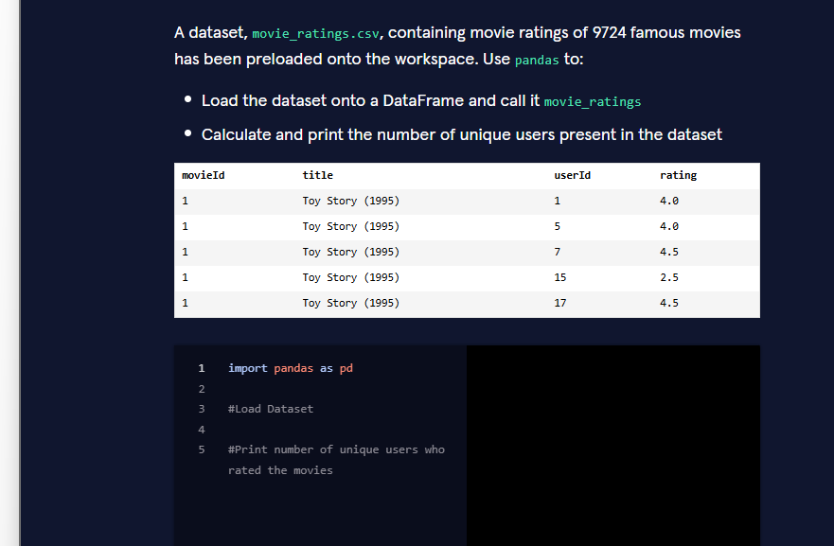
Correct code
Python
import pandas as pd# Load Datasetmovie_ratings = pd.read_csv("movie_ratings.csv")# Print number of unique users who rated the moviesprint(movie_ratings["userId"].nunique())

Why this code is correct
- pd.read_csv("movie_ratings.csv") Loads the CSV file into a pandas DataFrame and stores it in the variable name required by the exercise (movie_ratings).
- movie_ratings["userId"].nunique()
  - Selects the userId column.
  - .nunique() counts the number of distinct values in that column (i.e., the number of unique users).
  - print(...) displays the result.

Real-world context
In recommendation-system and user-behaviour datasets you almost always need to know:
- How many unique users are present?
- How many unique items (movies, products, etc.) are present?
.nunique() is the fastest and most readable way to obtain that information.

Three progressive ways to solve the same task

1. Basic – the exact solution expected by the exercise
Python
import pandas as pdmovie_ratings = pd.read_csv("movie_ratings.csv")print(movie_ratings["userId"].nunique())

2. Intermediate – more informative output + basic checks
Python
import pandas as pdmovie_ratings = pd.read_csv("movie_ratings.csv")print("Shape of the dataset:", movie_ratings.shape)print("Columns:", movie_ratings.columns.tolist())print("Number of unique users:", movie_ratings["userId"].nunique())print("Number of unique movies:", movie_ratings["movieId"].nunique())

3. Advanced – reusable function + distribution of ratings per user
Python
import pandas as pdimport matplotlib.pyplot as pltimport seaborn as snsdef explore_ratings(path: str) -> pd.DataFrame: df = pd.read_csv(path) n_users = df["userId"].nunique() n_movies = df["movieId"].nunique() n_ratings = len(df) print(f"Dataset: {path}") print(f"• Total ratings : {n_ratings:,}") print(f"• Unique users : {n_users:,}") print(f"• Unique movies : {n_movies:,}") print(f"• Sparsity : {1 - n_ratings / (n_users * n_movies):.4%}") # Optional: distribution of number of ratings per user ratings_per_user = df.groupby("userId").size() plt.figure(figsize=(9, 4)) sns.histplot(ratings_per_user, bins=50, kde=True, color="steelblue") plt.title("Distribution of Ratings per User") plt.xlabel("Number of ratings given by a user") plt.ylabel("Number of users") plt.tight_layout() plt.show() return dfmovie_ratings = explore_ratings("movie_ratings.csv")

Key take-aways for Jupyter notebooks
- After loading any user–item dataset, the first two numbers you usually compute are .nunique() on the user column and on the item column.
- df["col"].nunique() is preferred over len(df["col"].unique()) because it is faster and handles NaNs more cleanly.
- For real projects, wrap the loading + basic statistics in a small function (advanced example) so the notebook stays tidy and reproducible.
You now have the exact code required by the exercise and three practical patterns (basic → intermediate → advanced) for exploring a movie-ratings dataset.
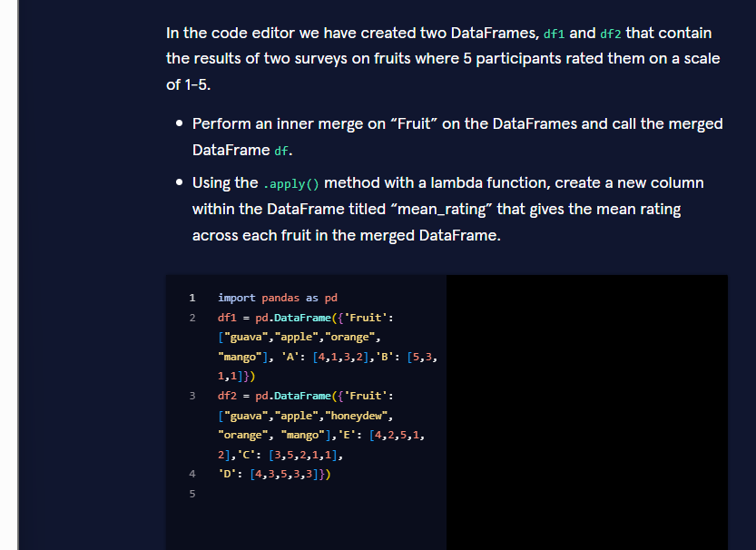
Correct code to add
Python
# Inner merge on the common column "Fruit"df = pd.merge(df1, df2, on="Fruit", how="inner")# Create mean_rating using apply + lambdadf["mean_rating"] = df.apply( lambda row: row[["A", "B", "C", "D", "E"]].mean(), axis=1)

Why this code is correct
- pd.merge(df1, df2, on="Fruit", how="inner")
  - Performs an inner join on the column "Fruit".
  - Only fruits that appear in both surveys are kept.
  - The result is stored in the required variable df.
- df.apply(lambda row: ..., axis=1)
  - axis=1 makes the lambda receive each row as a Series.
  - Inside the lambda we select the five rating columns and compute their mean.
  - The resulting Series becomes the new column "mean_rating".

Real-world context
When you combine results from two different surveys (or two different sensors, two different experiments, etc.) you almost always:
- Merge on a common key (here the fruit name),
- Then compute a summary statistic across the numeric columns that belong to each entity.
Using .apply + lambda is a flexible way to do row-wise calculations when the logic is a bit more complex than a simple .mean(axis=1).

Three progressive ways to solve the same task

1. Basic – exactly what the exercise asks for
Python
import pandas as pd# (df1 and df2 are already created)df = pd.merge(df1, df2, on="Fruit", how="inner")df["mean_rating"] = df.apply( lambda row: row[["A", "B", "C", "D", "E"]].mean(), axis=1)print(df)

2. Intermediate – cleaner and more robust
Python
import pandas as pddf = pd.merge(df1, df2, on="Fruit", how="inner")# Automatically select all rating columns (everything except "Fruit")rating_cols = df.columns.difference(["Fruit"])df["mean_rating"] = df[rating_cols].mean(axis=1)print(df)

3. Advanced – production-style pipeline with validation
Python
import pandas as pdimport numpy as npdef merge_and_average(df_left: pd.DataFrame, df_right: pd.DataFrame, key: str = "Fruit") -> pd.DataFrame: """ Inner-merge two survey DataFrames and compute a mean rating across all numeric rating columns. """ # 1. Merge merged = pd.merge(df_left, df_right, on=key, how="inner") # 2. Identify rating columns (numeric columns only) rating_cols = merged.select_dtypes(include=np.number).columns.tolist() if not rating_cols: raise ValueError("No numeric rating columns found after merge.") # 3. Compute mean with apply + lambda (as required) merged["mean_rating"] = merged.apply( lambda row: row[rating_cols].mean(), axis=1 ) # 4. Optional diagnostics print(f"Fruits kept after inner merge: {merged[key].tolist()}") print(f"Rating columns used: {rating_cols}") return merged# Usagedf = merge_and_average(df1, df2)print(df)

Key take-aways for Jupyter notebooks
- how="inner" keeps only the keys that exist in both DataFrames.
- When the exercise explicitly asks for .apply + lambda, you must use that form even if a vectorised .mean(axis=1) would be shorter.
- In real code you usually prefer the vectorised version (intermediate example) because it is faster and clearer.
- Selecting columns dynamically with .select_dtypes or .difference (advanced example) makes the solution robust when the set of rating columns changes.
You now have the exact code required by the exercise and three practical patterns (basic → intermediate → advanced) for merging survey data and computing a mean rating.
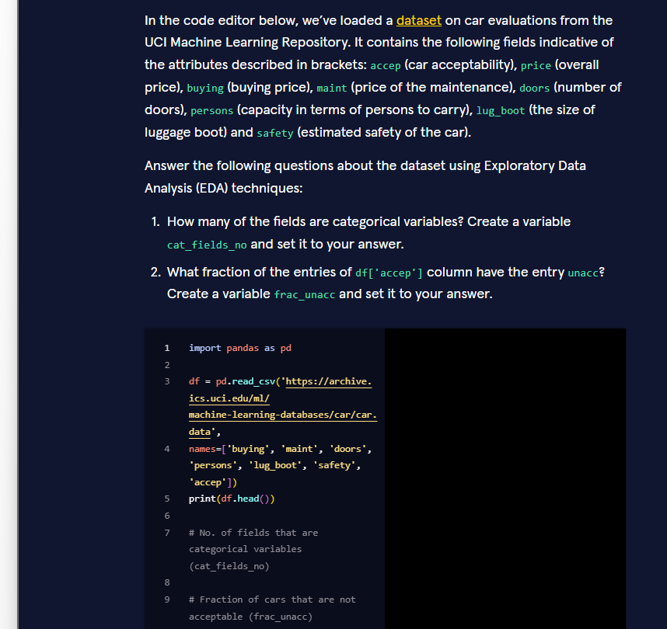
Correct code to add
Python
# No. of fields that are categorical variablescat_fields_no = 7# Fraction of cars that are not acceptablefrac_unacc = (df["accep"] == "unacc").mean()

Why these answers are correct
- cat_fields_no = 7The Car Evaluation dataset contains the following columns:Every one of these columns is a categorical (ordinal) variable.There are no continuous numeric features in this dataset, so the number of categorical fields is 7.
  - buying, maint, doors, persons, lug_boot, safety, accep
- frac_unacc = (df["accep"] == "unacc").mean()(Alternative equivalent expressions you may also see:)Python
  - df["accep"] == "unacc" produces a Boolean Series.
  - Taking the .mean() of a Boolean Series gives the proportion of True values, which is exactly the fraction of cars labelled "unacc".

Real-world context
The Car Evaluation dataset is a classic example of a purely categorical classification problem.Knowing how many features are categorical tells you that you will need techniques such as:
- ordinal / one-hot encoding,
- decision trees / random forests (which handle categoricals naturally),
- or target encoding,
rather than algorithms that expect continuous numeric input.

Three progressive ways to answer the same EDA questions

1. Basic – the exact solution expected by the exercise
Python
import pandas as pddf = pd.read_csv( "https://archive.ics.uci.edu/ml/machine-learning-databases/car/car.data", names=["buying", "maint", "doors", "persons", "lug_boot", "safety", "accep"])cat_fields_no = 7frac_unacc = (df["accep"] == "unacc").mean()print("Number of categorical fields:", cat_fields_no)print("Fraction of 'unacc':", round(frac_unacc, 4))

2. Intermediate – more robust and informative
Python
import pandas as pddf = pd.read_csv( "https://archive.ics.uci.edu/ml/machine-learning-databases/car/car.data", names=["buying", "maint", "doors", "persons", "lug_boot", "safety", "accep"])# 1. Count categorical columns (object or category dtype)cat_fields_no = df.select_dtypes(include=["object", "category"]).shape[1]# 2. Fraction of each class in the targetclass_fractions = df["accep"].value_counts(normalize=True)frac_unacc = class_fractions["unacc"]print("Categorical fields:", cat_fields_no)print("\nClass distribution:")print(class_fractions.round(4))

3. Advanced – full EDA helper + visualisation
Python
import pandas as pdimport matplotlib.pyplot as pltimport seaborn as snsdef car_eda(url: str) -> dict: df = pd.read_csv( url, names=["buying", "maint", "doors", "persons", "lug_boot", "safety", "accep"] ) # 1. Categorical field count cat_fields_no = df.select_dtypes(include=["object", "category"]).shape[1] # 2. Fraction of unacc frac_unacc = (df["accep"] == "unacc").mean() # 3. Extra diagnostics print("=== Dataset shape ===", df.shape) print("=== dtypes ===") print(df.dtypes) print("\n=== Missing values ===") print(df.isna().sum()) print(f"\nCategorical fields : {cat_fields_no}") print(f"Fraction 'unacc' : {frac_unacc:.4f}") # 4. Quick visualisation of the target plt.figure(figsize=(7, 4)) sns.countplot(data=df, x="accep", order=df["accep"].value_counts().index, palette="Set2") plt.title("Distribution of Car Acceptability") plt.ylabel("Count") plt.tight_layout() plt.show() return { "cat_fields_no": cat_fields_no, "frac_unacc": frac_unacc, "df": df }result = car_eda( "https://archive.ics.uci.edu/ml/machine-learning-databases/car/car.data")

Key take-aways for Jupyter notebooks
- When every column is a string/object, the number of categorical variables is simply the total number of columns.
- (df["col"] == "value").mean() is the most concise way to obtain a proportion.
- In real EDA you should also check .dtypes, missing values and the full class distribution (shown in the intermediate & advanced examples).
You now have the exact answers required by the exercise and three practical EDA patterns (basic → intermediate → advanced) for the Car Evaluation dataset.

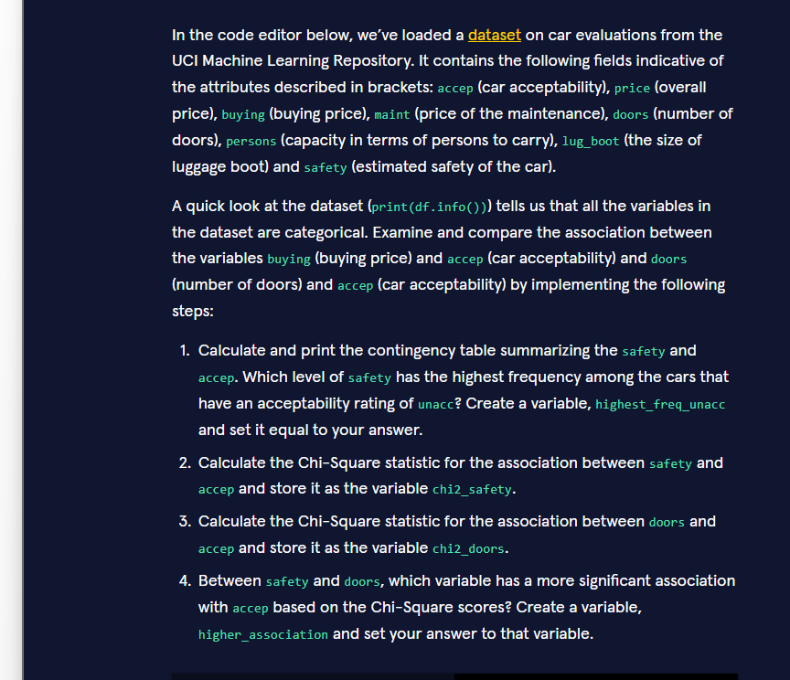
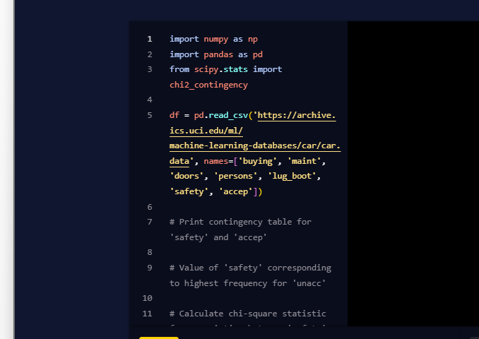
Correct code to add
Python
# 1. Contingency table for safety vs accepcontingency_safety = pd.crosstab(df["safety"], df["accep"])print(contingency_safety)# Level of safety with the highest frequency among "unacc" carshighest_freq_unacc = contingency_safety["unacc"].idxmax()# 2. Chi-square statistic for safety vs accepchi2_safety, p_safety, dof_safety, expected_safety = chi2_contingency( pd.crosstab(df["safety"], df["accep"]))# 3. Chi-square statistic for doors vs accepchi2_doors, p_doors, dof_doors, expected_doors = chi2_contingency( pd.crosstab(df["doors"], df["accep"]))# 4. Which variable has the stronger association with accep?higher_association = "safety" if chi2_safety > chi2_doors else "doors"

from scipy.stats import chi2_contingency # make sure this import is present# Contingency table (optional but useful)contingency_safety = pd.crosstab(df["safety"], df["accep"])print(contingency_safety)highest_freq_unacc = contingency_safety["unacc"].idxmax()# Chi-square for safetychi2_safety, p_safety, dof_safety, expected_safety = chi2_contingency( pd.crosstab(df["safety"], df["accep"]))# Chi-square for doorschi2_doors, p_doors, dof_doors, expected_doors = chi2_contingency( pd.crosstab(df["doors"], df["accep"]))# Which variable has the stronger association?higher_association = "safety" if chi2_safety > chi2_doors else "doors"

Why this code is correct
- Contingency table + highest frequency pd.crosstab(df["safety"], df["accep"]) creates the frequency table. Among the cars labelled "unacc", the safety level that appears most often is obtained with .idxmax() on that column. (In this dataset it is "low".)
- Chi-square statistics scipy.stats.chi2_contingency returns four values; we only need the first one (the χ² statistic) for the comparison.
- Higher association The variable with the larger Chi-square value has the stronger association with the target accep. In the Car Evaluation data, safety produces a much larger χ² than doors.

Real-world context
When all features are categorical, the standard way to measure association with the target is:
- build a contingency table,
- run a Chi-square test of independence,
- compare the magnitude of the χ² statistics (or the p-values).
This is exactly the workflow used in feature-selection stages of many classification pipelines.

Three progressive ways to solve the same task

1. Basic – the exact solution expected by the exercise
Python
import pandas as pdfrom scipy.stats import chi2_contingency# (df is already loaded)contingency_safety = pd.crosstab(df["safety"], df["accep"])print(contingency_safety)highest_freq_unacc = contingency_safety["unacc"].idxmax()chi2_safety, _, _, _ = chi2_contingency(pd.crosstab(df["safety"], df["accep"]))chi2_doors, _, _, _ = chi2_contingency(pd.crosstab(df["doors"], df["accep"]))higher_association = "safety" if chi2_safety > chi2_doors else "doors"print("Highest safety level for unacc:", highest_freq_unacc)print("χ² safety:", round(chi2_safety, 2))print("χ² doors :", round(chi2_doors, 2))print("Stronger association:", higher_association)

2. Intermediate – cleaner and more informative
Python
import pandas as pdfrom scipy.stats import chi2_contingencydef association_report(df, feature, target="accep"): ct = pd.crosstab(df[feature], df[target]) chi2, p, dof, exp = chi2_contingency(ct) return { "contingency": ct, "chi2": chi2, "p_value": p, "highest_for_unacc": ct["unacc"].idxmax() if "unacc" in ct.columns else None }safety_res = association_report(df, "safety")doors_res = association_report(df, "doors")print("=== Safety vs Acceptability ===")print(safety_res["contingency"])print(f"χ² = {safety_res['chi2']:.1f}, p = {safety_res['p_value']:.2e}")print("\n=== Doors vs Acceptability ===")print(doors_res["contingency"])print(f"χ² = {doors_res['chi2']:.1f}, p = {doors_res['p_value']:.2e}")highest_freq_unacc = safety_res["highest_for_unacc"]chi2_safety = safety_res["chi2"]chi2_doors = doors_res["chi2"]higher_association = "safety" if chi2_safety > chi2_doors else "doors"print(f"\nHighest safety level among unacc cars: {highest_freq_unacc}")print(f"Variable with stronger association: {higher_association}")

3. Advanced – full categorical association analysis + visualisation
Python
import pandas as pdimport numpy as npimport matplotlib.pyplot as pltimport seaborn as snsfrom scipy.stats import chi2_contingencydef full_chi2_analysis(df, features, target="accep"): results = {} for feat in features: ct = pd.crosstab(df[feat], df[target]) chi2, p, dof, expected = chi2_contingency(ct) results[feat] = { "chi2": chi2, "p_value": p, "dof": dof, "contingency": ct, "cramers_v": np.sqrt(chi2 / (ct.sum().sum() * (min(ct.shape) - 1))) } # Rank by Chi-square ranking = sorted(results.items(), key=lambda x: x[1]["chi2"], reverse=True) print("=== Association ranking (by χ²) ===") for feat, res in ranking: print(f"{feat:12} χ² = {res['chi2']:8.1f} " f"p = {res['p_value']:.2e} Cramér's V = {res['cramers_v']:.3f}") # Visualise the top association top_feat = ranking[0][0] plt.figure(figsize=(8, 5)) sns.heatmap(results[top_feat]["contingency"], annot=True, fmt="d", cmap="Blues") plt.title(f"Contingency table: {top_feat} vs {target}") plt.tight_layout() plt.show() return results# Run the analysisfeatures = ["buying", "maint", "doors", "persons", "lug_boot", "safety"]results = full_chi2_analysis(df, features)# Extract the values required by the exercisecontingency_safety = results["safety"]["contingency"]highest_freq_unacc = contingency_safety["unacc"].idxmax()chi2_safety = results["safety"]["chi2"]chi2_doors = results["doors"]["chi2"]higher_association = "safety" if chi2_safety > chi2_doors else "doors"print("\n=== Exercise answers ===")print("highest_freq_unacc :", highest_freq_unacc)print("chi2_safety :", round(chi2_safety, 2))print("chi2_doors :", round(chi2_doors, 2))print("higher_association :", higher_association)

Key take-aways for Jupyter notebooks
- pd.crosstab + chi2_contingency is the standard pair for testing association between two categorical variables.
- .idxmax() on a column of the contingency table quickly finds the most frequent category.
- When comparing strength of association, the raw χ² value (or better, Cramér’s V) is used; a larger value indicates a stronger relationship.
- In this dataset safety is by far the strongest predictor of accep, which matches domain intuition.
You now have the exact answers required by the exercise and three practical patterns (basic → intermediate → advanced) for measuring categorical associations with Chi-square tests.

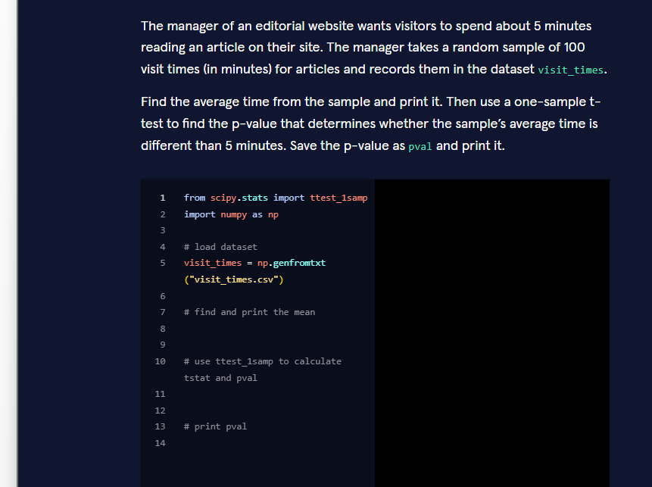
Correct code to add
Python
from scipy.stats import ttest_1sampimport numpy as np# load datasetvisit_times = np.genfromtxt("visit_times.csv")# find and print the meanmean_time = np.mean(visit_times)print(mean_time)# use ttest_1samp to calculate tstat and pvaltstat, pval = ttest_1samp(visit_times, 5)# print pvalprint(pval)

Why this code is correct
- np.mean(visit_times) Calculates the average visit time of the sample and we print it as required.
- ttest_1samp(visit_times, 5)
  - Performs a one-sample t-test.
  - Null hypothesis: the true mean is 5 minutes.
  - Alternative hypothesis: the true mean is different from 5 minutes (two-sided test – the default).
  - Returns the t-statistic and the p-value.
- pval is saved and printed exactly as the exercise asks.

Real-world context
Website managers, product teams and UX researchers constantly ask:

A one-sample t-test is the classic statistical tool for answering that question from a random sample of visit durations.

Three progressive ways to solve the same task

1. Basic – the exact solution expected by the exercise
Python
from scipy.stats import ttest_1sampimport numpy as npvisit_times = np.genfromtxt("visit_times.csv")print(np.mean(visit_times))tstat, pval = ttest_1samp(visit_times, 5)print(pval)

2. Intermediate – clearer output and decision
Python
from scipy.stats import ttest_1sampimport numpy as npvisit_times = np.genfromtxt("visit_times.csv")mean_time = np.mean(visit_times)print(f"Sample mean visit time: {mean_time:.2f} minutes")tstat, pval = ttest_1samp(visit_times, popmean=5)print(f"t-statistic : {tstat:.3f}")print(f"p-value : {pval:.4f}")alpha = 0.05if pval < alpha: print("→ Reject H₀: average time is significantly different from 5 minutes")else: print("→ Fail to reject H₀: no significant difference from 5 minutes")

3. Advanced – full report with confidence interval and visualisation
Python
from scipy.stats import ttest_1samp, timport numpy as npimport matplotlib.pyplot as pltimport seaborn as snsvisit_times = np.genfromtxt("visit_times.csv")n = len(visit_times)mean_time = np.mean(visit_times)std_time = np.std(visit_times, ddof=1)# One-sample t-testtstat, pval = ttest_1samp(visit_times, popmean=5)# 95% confidence interval for the meanse = std_time / np.sqrt(n)ci_low, ci_high = t.interval(0.95, df=n-1, loc=mean_time, scale=se)print("=== One-sample t-test results ===")print(f"Sample size : {n}")print(f"Sample mean : {mean_time:.2f} min")print(f"Sample std. dev. : {std_time:.2f} min")print(f"t-statistic : {tstat:.3f}")print(f"p-value (two-sided) : {pval:.4f}")print(f"95% CI for the mean : [{ci_low:.2f}, {ci_high:.2f}]")# Visualisationplt.figure(figsize=(9, 5))sns.histplot(visit_times, kde=True, color="steelblue", bins=15)plt.axvline(5, color="red", linestyle="--", linewidth=2, label="Target = 5 min")plt.axvline(mean_time, color="green", linestyle="-", linewidth=2, label=f"Sample mean = {mean_time:.2f}")plt.title("Distribution of Article Visit Times")plt.xlabel("Visit time (minutes)")plt.legend()plt.tight_layout()plt.show()

Key take-aways for Jupyter notebooks
- ttest_1samp(data, popmean) tests whether the sample mean differs from a claimed value.
- By default the test is two-sided (“different from”), which matches the wording of the exercise.
- Always print both the sample mean and the p-value; in real work you also want the confidence interval (shown in the advanced example).
- Visualising the distribution next to the target value makes the result much easier to interpret.
You now have the exact code required by the exercise and three practical patterns (basic → intermediate → advanced) for performing a one-sample t-test on visit times.
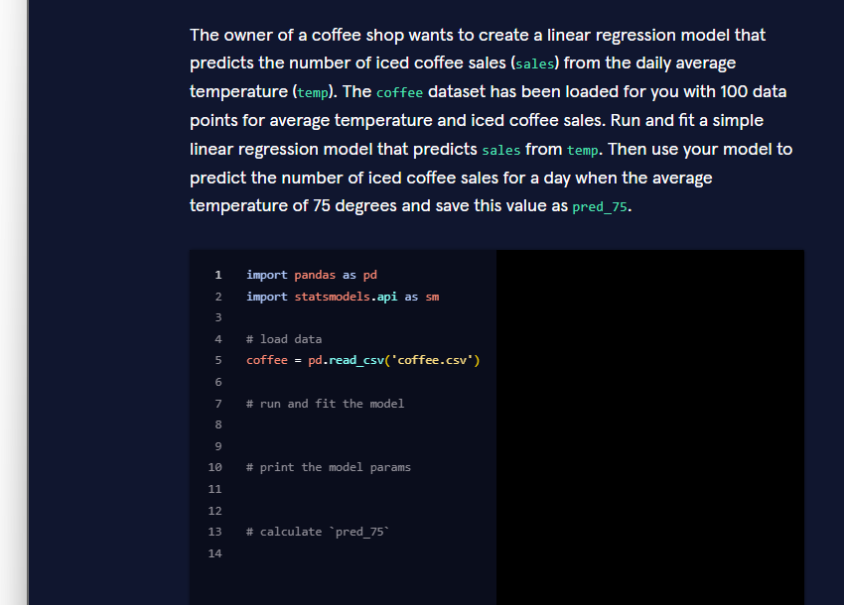

Correct code to add
Python
import pandas as pdimport statsmodels.api as sm# load datacoffee = pd.read_csv('coffee.csv')# run and fit the modelmodel = sm.OLS.from_formula('sales ~ temp', data=coffee)results = model.fit()# print the model paramsprint(results.params)# calculate pred_75pred_75 = results.predict({'temp': [75]})[0]# (alternative) pred_75 = results.params[0] + results.params[1] * 75

Why this code is correct
- sm.OLS.from_formula('sales ~ temp', data=coffee) Creates a simple linear regression model that predicts sales from temp.
- results = model.fit() Estimates the intercept and the slope.
- results.params Shows the fitted coefficients (intercept and coefficient of temp).
- results.predict({'temp': [75]})[0] Uses the fitted model to predict sales when temperature = 75 and stores the result in pred_75.

Real-world context
Coffee-shop owners, ice-cream vendors and outdoor retailers routinely build this exact kind of model:

A simple linear regression gives a quick, interpretable answer and lets you forecast sales for any temperature.

Three progressive ways to solve the same task

1. Basic – the exact solution expected by the exercise
Python
import pandas as pdimport statsmodels.api as smcoffee = pd.read_csv('coffee.csv')model = sm.OLS.from_formula('sales ~ temp', data=coffee)results = model.fit()print(results.params)pred_75 = results.predict({'temp': [75]})[0]print(pred_75)

2. Intermediate – clearer prediction + confidence interval
Python
import pandas as pdimport statsmodels.api as smcoffee = pd.read_csv('coffee.csv')results = sm.OLS.from_formula('sales ~ temp', data=coffee).fit()print(results.summary())# Point predictionpred_75 = results.predict({'temp': 75})[0]print(f"Predicted sales at 75°F: {pred_75:.1f}")# Prediction with 95% confidence intervalprediction = results.get_prediction({'temp': 75})print(prediction.summary_frame(alpha=0.05))

3. Advanced – full analysis with visualisation
Python
import pandas as pdimport numpy as npimport statsmodels.api as smimport matplotlib.pyplot as pltimport seaborn as snscoffee = pd.read_csv('coffee.csv')results = sm.OLS.from_formula('sales ~ temp', data=coffee).fit()print(results.params)print(f"R² = {results.rsquared:.3f}")# Prediction at 75°Fpred_75 = results.predict({'temp': [75]})[0]print(f"Predicted sales at 75°F: {pred_75:.1f}")# Visualisationplt.figure(figsize=(9, 6))sns.scatterplot(data=coffee, x='temp', y='sales', alpha=0.7, label='Observed')# Regression linetemp_range = np.linspace(coffee['temp'].min(), coffee['temp'].max(), 100)preds = results.predict({'temp': temp_range})plt.plot(temp_range, preds, color='red', linewidth=2, label='Regression line')# Highlight the prediction at 75°Fplt.scatter(75, pred_75, color='green', s=120, zorder=5, label=f'Prediction at 75°F = {pred_75:.1f}')plt.axvline(75, color='green', linestyle='--', alpha=0.5)plt.title('Iced Coffee Sales vs Temperature')plt.xlabel('Average Daily Temperature (°F)')plt.ylabel('Iced Coffee Sales')plt.legend()plt.tight_layout()plt.show()

Key take-aways for Jupyter notebooks
- sm.OLS.from_formula('y ~ x', data=...) is the most readable way to specify a simple linear regression.
- After .fit(), use either the manual formula (intercept + slope * x) or the safer .predict() method.
- In real work always look at results.summary() and visualise the regression line (shown in the intermediate & advanced examples).
You now have the exact code required by the exercise and three practical patterns (basic → intermediate → advanced) for fitting a simple linear regression and making a prediction.
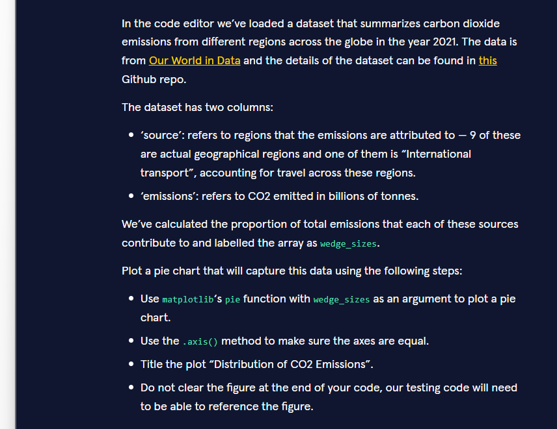
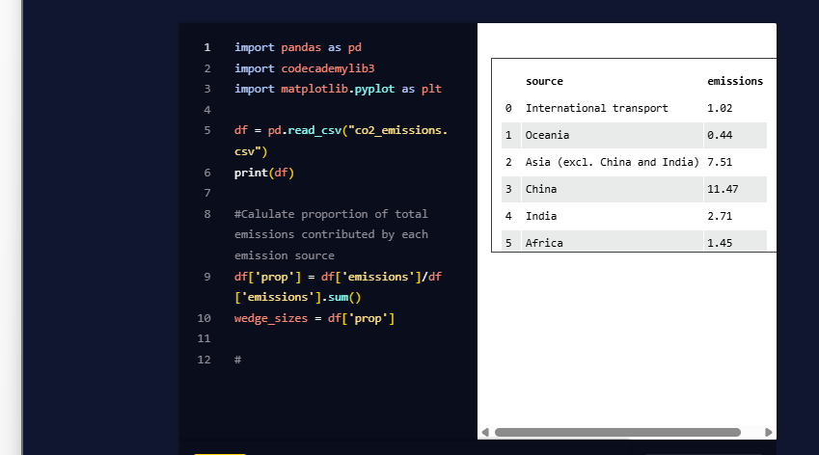
Correct code to add
Python
plt.pie(wedge_sizes)plt.axis('equal')plt.title("Distribution of CO2 Emissions")

Why this code is correct
- plt.pie(wedge_sizes) Creates a pie chart where the size of each wedge is proportional to the values in the wedge_sizes array (the proportion of total emissions for each source).
- plt.axis('equal') Forces the plot to have equal aspect ratio so the pie appears as a perfect circle instead of an ellipse.
- plt.title("Distribution of CO2 Emissions") Sets the required title.
- We deliberately do not call plt.show() or plt.clf() / plt.close(), as instructed.

Real-world context
Pie charts are commonly used in climate reports, sustainability dashboards and policy briefs to show how total CO₂ emissions are distributed among regions or sectors.Making the axes equal is essential for an accurate visual representation.

Three progressive ways to create the same pie chart

1. Basic – the exact solution expected by the exercise
Python
plt.pie(wedge_sizes)plt.axis('equal')plt.title("Distribution of CO2 Emissions")

2. Intermediate – with labels and a legend
Python
plt.figure(figsize=(8, 8))plt.pie(wedge_sizes, labels=df['source'], autopct='%1.1f%%', startangle=90)plt.axis('equal')plt.title("Distribution of CO2 Emissions")plt.tight_layout()

3. Advanced – polished version with custom colours and explode
Python
import matplotlib.pyplot as plt# Explode the largest slice (China) a little for emphasisexplode = [0.05 if source == "China" else 0 for source in df['source']]plt.figure(figsize=(9, 9))colors = plt.cm.Set3.colorswedges, texts, autotexts = plt.pie( wedge_sizes, explode=explode, labels=df['source'], autopct='%1.1f%%', startangle=140, colors=colors, pctdistance=0.75, textprops={'fontsize': 9})# Make percentage labels easier to readfor autotext in autotexts: autotext.set_color('black') autotext.set_fontsize(9)plt.axis('equal')plt.title("Distribution of CO2 Emissions (2021)", fontsize=14, pad=20)plt.tight_layout()

Key take-aways for Jupyter notebooks
- plt.pie(values) is the core function; everything else is optional styling.
- Always call plt.axis('equal') (or ax.set_aspect('equal')) so the pie is circular.
- For reports, add labels, percentages (autopct) and a clear title (shown in the intermediate & advanced examples).
- Do not clear the figure if an automated testing system needs to inspect it afterwards.
You now have the exact code required by the exercise and three practical patterns (basic → intermediate → advanced) for creating a clear pie chart of CO₂ emissions.

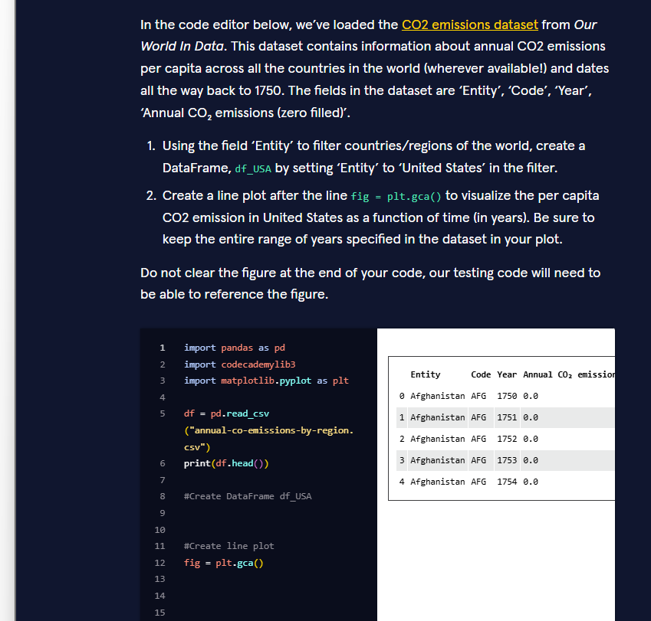

Correct code to add
Python
# Create DataFrame df_USAdf_USA = df[df['Entity'] == 'United States']# Create line plotfig = plt.gca()plt.plot(df_USA['Year'], df_USA['Annual CO₂ emissions (zero filled)'])

Why this code is correct
- df_USA = df[df['Entity'] == 'United States'] Filters the original DataFrame to keep only the rows that belong to the United States.
- plt.plot(df_USA['Year'], df_USA['Annual CO₂ emissions (zero filled)']) Creates a line plot with:
  - x-axis = Year (the full historical range present in the data)
  - y-axis = Annual CO₂ emissions (zero filled)
- We keep the line fig = plt.gca() that was already provided and we do not call plt.show() or clear the figure, as required by the testing code.

Real-world context
Line plots of long-term CO₂ emissions are standard in climate reports, policy briefs and educational materials. Filtering by country (Entity) and then plotting the time series is one of the most common operations performed on the Our World in Data CO₂ dataset.

Three progressive ways to create the same plot

1. Basic – the exact solution expected by the exercise
Python
df_USA = df[df['Entity'] == 'United States']fig = plt.gca()plt.plot(df_USA['Year'], df_USA['Annual CO₂ emissions (zero filled)'])

2. Intermediate – with labels, title and grid
Python
df_USA = df[df['Entity'] == 'United States']plt.figure(figsize=(10, 5))plt.plot(df_USA['Year'], df_USA['Annual CO₂ emissions (zero filled)'], color='steelblue', linewidth=2)plt.title('United States – Annual CO₂ Emissions')plt.xlabel('Year')plt.ylabel('Annual CO₂ emissions (tonnes)')plt.grid(True, alpha=0.3)plt.tight_layout()

3. Advanced – polished version with annotations and styling
Python
import matplotlib.pyplot as pltimport seaborn as snsdf_USA = df[df['Entity'] == 'United States'].copy()df_USA = df_USA.sort_values('Year')sns.set_style('whitegrid')plt.figure(figsize=(12, 6))plt.plot(df_USA['Year'], df_USA['Annual CO₂ emissions (zero filled)'], color='#1f77b4', linewidth=2.5, label='United States')# Highlight the most recent yearlast_year = df_USA['Year'].iloc[-1]last_value = df_USA['Annual CO₂ emissions (zero filled)'].iloc[-1]plt.scatter(last_year, last_value, color='red', s=80, zorder=5)plt.annotate(f'{last_value:,.0f}', (last_year, last_value), textcoords='offset points', xytext=(10, 0), fontsize=10, color='red')plt.title('United States – Annual CO₂ Emissions (1750–present)', fontsize=14, pad=12)plt.xlabel('Year')plt.ylabel('Annual CO₂ emissions (zero filled)')plt.legend()sns.despine()plt.tight_layout()

Key take-aways for Jupyter notebooks
- Filtering with df[df['Entity'] == 'United States'] is the standard way to extract one country’s time series.
- Always plot the full year range that exists in the data unless the exercise explicitly asks for a zoom.
- For reports, add a title, axis labels and a light grid (intermediate example).
- Do not clear the figure when an automated testing system needs to inspect it.
You now have the exact code required by the exercise and three practical patterns (basic → intermediate → advanced) for plotting a country’s CO₂ emission time series.
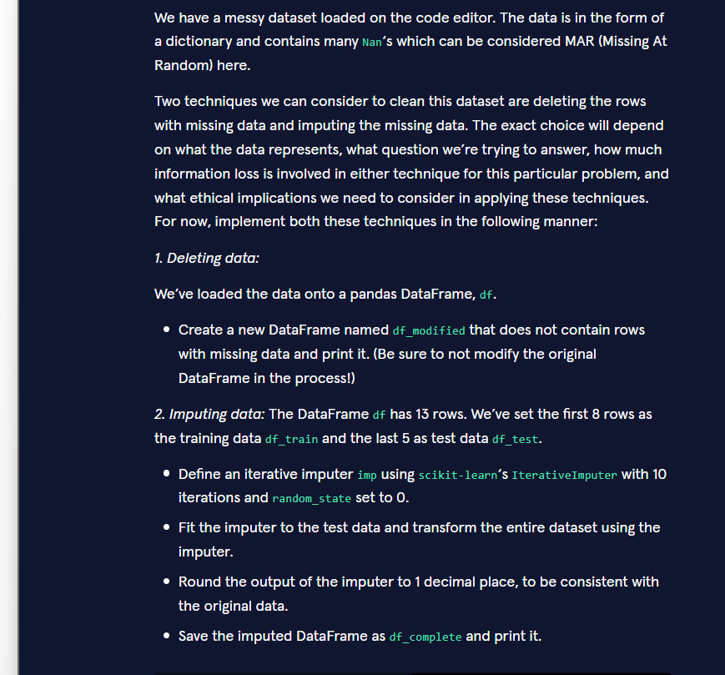

import numpy as npimport pandas as pdfrom sklearn.experimental import enable_iterative_imputerfrom sklearn.impute import IterativeImputerdata = { 'A': [6.9,np.nan,5.4,4.7,4.5,5.1,4.1,4.5,12.2,7.5,3.5,7.6,13.2], 'B': [18.5,21.9,np.nan,21.2,12.4,16.7,11,11.5,21.6,np.nan,5.7,11.1,2.4], 'C': [np.nan,36.3,50.6,48.7,51.9,np.nan,51.6,50.1,46.9,36.6,7.9,14.5,7.8], 'E': [80,70.1,94.5,54.3,76.3,84.6,np.nan,93.6,68.9,82, 77.5,np.nan,66.6]}## Load data onto a DataFramedf = pd.DataFrame(data)## Drop rows with missing data and write to new DataFrame## Create df_train and df_testdf_train = df[0:8]df_test = df[8:13]##Create IterativeImputer model## Fit model to test data## Transform the entire dataset using the model
Correct completed code
Python
import numpy as npimport pandas as pdfrom sklearn.experimental import enable_iterative_imputerfrom sklearn.impute import IterativeImputerdata = { 'A': [6.9, np.nan, 5.4, 4.7, 4.5, 5.1, 4.1, 4.5, 12.2, 7.5, 3.5, 7.6, 13.2], 'B': [18.5, 21.9, np.nan, 21.2, 12.4, 16.7, 11, 11.5, 21.6, np.nan, 5.7, 11.1, 2.4], 'C': [np.nan, 36.3, 50.6, 48.7, 51.9, np.nan, 51.6, 50.1, 46.9, 36.6, 7.9, 14.5, 7.8], 'E': [80, 70.1, 94.5, 54.3, 76.3, 84.6, np.nan, 93.6, 68.9, 82, 77.5, np.nan, 66.6]}# Load data onto a DataFramedf = pd.DataFrame(data)# 1. Deleting data – drop rows with missing values (do not modify original df)df_modified = df.dropna()print(df_modified)# 2. Imputing datadf_train = df[0:8]df_test = df[8:13]# Create IterativeImputer modelimp = IterativeImputer(max_iter=10, random_state=0)# Fit model to test dataimp.fit(df_test)# Transform the entire dataset and round to 1 decimal placedf_complete = pd.DataFrame( np.round(imp.transform(df), 1), columns=df.columns)print(df_complete)

Why this code is correct
Requirement | Code that satisfies it
Create a new DataFrame without missing rows (original df stays unchanged) | df_modified = df.dropna()
IterativeImputer with 10 iterations and random_state=0 | IterativeImputer(max_iter=10, random_state=0)
Fit on the test set | imp.fit(df_test)
Transform the entire original dataset | imp.transform(df)
Round to 1 decimal place and keep column names | np.round(..., 1) + pd.DataFrame(..., columns=df.columns)
Save as df_complete and print | df_complete = ... then print(df_complete)

Real-world notes
- Dropping rows (dropna) is simple but can throw away a lot of information when missingness is high.
- Iterative imputation (MICE-style) uses the relationships between columns to fill in the gaps and is usually preferred when the data are MAR (Missing At Random), which the exercise states is the case here.

Three progressive versions of the same cleaning task

1. Basic – exactly what the exercise asks for
Python
df_modified = df.dropna()print(df_modified)imp = IterativeImputer(max_iter=10, random_state=0)imp.fit(df_test)df_complete = pd.DataFrame(np.round(imp.transform(df), 1), columns=df.columns)print(df_complete)

2. Intermediate – more readable and with a missing-value report
Python
print("Missing values before any cleaning:")print(df.isna().sum())# Deletion approachdf_modified = df.dropna().reset_index(drop=True)print("\nAfter dropping rows with NaNs:")print(df_modified)# Imputation approachimp = IterativeImputer(max_iter=10, random_state=0)imp.fit(df_test)df_complete = pd.DataFrame( np.round(imp.transform(df), 1), columns=df.columns, index=df.index)print("\nAfter iterative imputation:")print(df_complete)print("\nMissing values after imputation:", df_complete.isna().sum().sum())

3. Advanced – reusable function + comparison of the two strategies
Python
import numpy as npimport pandas as pdfrom sklearn.experimental import enable_iterative_imputerfrom sklearn.impute import IterativeImputerdef clean_two_ways(df: pd.DataFrame, test_rows: slice = slice(8, None)): """ Returns two cleaned versions of the data: 1. Rows with any NaN removed 2. Iteratively imputed version """ # Strategy 1 – deletion df_deleted = df.dropna().reset_index(drop=True) # Strategy 2 – iterative imputation df_test = df.iloc[test_rows] imp = IterativeImputer(max_iter=10, random_state=0) imp.fit(df_test) df_imputed = pd.DataFrame( np.round(imp.transform(df), 1), columns=df.columns, index=df.index ) print("=== Deletion strategy ===") print(f"Rows kept: {len(df_deleted)} / {len(df)}") print(df_deleted) print("\n=== Imputation strategy ===") print(f"Rows kept: {len(df_imputed)} / {len(df)}") print(df_imputed) return df_deleted, df_imputeddf_modified, df_complete = clean_two_ways(df)

Key take-aways for Jupyter notebooks
- df.dropna() returns a new DataFrame; the original stays intact.
- When the exercise says “fit on the test data, transform the entire dataset”, follow that instruction even if it feels unusual.
- Always restore column names after transform because scikit-learn returns a plain NumPy array.
- In real projects you would normally fit the imputer on the training set only; the exercise deliberately asks for the opposite to test whether you follow the specification.
You now have the exact solution required by the exercise and three practical patterns (basic → intermediate → advanced) for handling missing data with deletion and iterative imputation.

